|  |  |  |
| --- | --- | --- |
| **The Edward S. Rogers Sr. Department of**  **Electrical and Computer Engineering**  **University of Toronto** | | |
| **ECE496Y Design Project Course**  **Group Final Report** | | |
| Title: Reflection Chatbot | | |
| Team #: | 2019038 | |
| Team members: | Name: | Email: |
| J. Matthew Chapleau | matthew.chapleau@mail.utoronto.ca |
| Kuan Ying Chern | tim.chern@mail.utoronto.ca |
|  | Rajarupan Sampanthan | rajarupan.sampanthan@mail.utoronto.ca |
|  | Shihan Zhang | cora.zhang@mail.utoronto.ca |
| Supervisor: | Jonathan Rose | |
| Section #: | 0101 | |
| Administrator: | Hans Kunov | |
| Submission Date: | March 24, 2020 | |

**Group Final Report Attribution Table**

This table should be filled out to accurately reflect who contributed to each section of the report and what they contributed. Provide a **column** for each student, a **row** for each major section of the report, and the appropriate codes (e.g. ‘RD, MR’) in each of the necessary **cells** in the table. You may expand the table, inserting rows as needed, but you should not require more than two pages. The original completed and signed form must be included in the hardcopies of the final report. Please make a copy of it for your own reference.

|  |  |  |  |  |
| --- | --- | --- | --- | --- |
| **Section** | **Student Names** | | | |
| Kuan Ying Chern | J. Matthew Chapleau | Rajarupan Sampanthan | Shihan Zhang |
| *Executive Summary* | *ET* | *ET* | *RS RD MR ET* | *RS, ET,MR* |
| *Group Highlights* |  | *RS, RD, ET* | *RS ET RD* |  |
| *Background and Motivation* |  | *ET* | *RD RS MR ET* |  |
| *Project Goal* |  | *RS, RD, ET* |  |  |
| *Project Requirements* | *RS, RD, MR, ET* | *RS, RD, MR, ET* | *ET* |  |
| *Technical Design* | *RD, ET, MR* | *ET* |  |  |
| *System-Level Overview* | *RD, ET, MR* | *ET* |  | *RS* |
| *System Block Diagram* | *RD, ET, MR* | *ET* |  |  |
| *Module-Level Descriptions and Design* | *RD, RS, ET, MR* | *RD, ET* |  | *RS, ET, MR* |
| *Assessment of Final Design* | *RS, RD, ET, MR* | *RS, RD, ET* | *ET* |  |
| *Testing and Verification (and referenced appendices)* | *RS, ET* | *RS, RD, ET* | *RD RS ET* |  |
| *Summary and Conclusions* |  |  | *ET* | *RS, RD, ET, MR* |
| *All* | *FP* | *FP* | *FP* | *FP* |

**Abbreviation Codes:**

Fill in abbreviations for roles for each of the required content elements. You do not have to fill in every cell. The “**All**” row refers to the complete report and should indicate who was responsible for the final compilation and final read through of the completed document.

RS – responsible for research of information

RD – wrote the first draft

MR – responsible for major revision

ET – edited for grammar, spelling, and expression

OR – other

“All” row abbreviations:

FP – final read through of complete document for flow and consistency

CM – responsible for compiling the elements into the complete document

OR - other

If you put OR (other) in a cell please put it in as OR1, OR2, etc. Explain briefly below the role referred to:

OR1: enter brief description here

OR2: enter brief description here

**Signatures**

By signing below, you verify that you have read the attribution table and agree that it accurately reflects your contribution to this document.

|  |  |  |  |  |  |
| --- | --- | --- | --- | --- | --- |
| **Name** | J. Matthew Chapleau | **Signature** |  | **Date:** | March 23, 2020 |
| **Name** | Shihan Zhang | **Signature** |  | **Date:** | March 23, 2020 |
| **Name** | Kuan Ying Chern | **Signature** |  | **Date:** | March 23, 2020 |
| **Name** | Rajarupan Sampanthan | **Signature** |  | **Date:** | March 23, 2020 |

**Voluntary Document Release Consent Form**

To all ECE496 students:

To better help future students, we would like to provide examples that are drawn from excerpts of past student reports. The examples will be used to illustrate general communication principles as well as how the document guidelines can be applied to a variety of categories of design projects (e.g. electronics, computer, software, networking, research).

Any material chosen for the examples will be altered so that all names are removed. In addition, where possible, much of the technical details will also be removed so that the structure or presentation style are highlighted rather than the original technical content. These examples will be made available to students on the course website, and in general may be accessible by the public. The original reports will not be released but will be accessible only to the course instructors and administrative staff.

Participation is completely voluntary and students may refuse to participate or may withdraw their permission at any time. Reports will only be used with the signed consent of all team members. Participating will have no influence on the grading of your work and there is no penalty for not taking part.

If your group agrees to take part, please have all members sign the bottom of this form. The original completed and signed form should be included in the hardcopies of the final report.

Sincerely,

Khoman Phang

Phil Anderson

ECE496Y Course Coordinators

**Consent Statement**

We verify that we have read the above letter and are giving permission for the ECE496 course coordinator to use our reports as outlined above.

Team #: 38 Project Title: Reflection Chatbot

Supervisor: Jonathan Rose Administrator: Hans Kunov

|  |  |  |  |  |  |
| --- | --- | --- | --- | --- | --- |
| **Name** | J. Matthew Chapleau | **Signature** |  | **Date:** | March 23, 2020 |
| **Name** | Kuan Ying Chern | **Signature** |  | **Date:** | March 23, 2020 |
| **Name** | Rajarupan Sampanthan | **Signature** |  | **Date:** | March 23, 2020 |
| **Name** | Shihan Zhang | **Signature** |  | **Date:** | March 23, 2020 |

**Executive Summary (author: Rajarupan Sampanthan)**

The goal of this project is to create a text-based chatbot that helps users to reflect on their values and actions. The intended users of the chatbot are post-secondary students; as such, 15 common values of students are supported in this project. The application is made of three main components: a user interface, a Dialogue Engine, and a NLP Unit. The chatbot models its responses based on techniques commonly used in Motivational Interviewing. All conversations take place using a web application hosted using AWS (Amazon Web Services) and Google Firebase. All data will be encrypted via SSL which ensures the data is kept private when traversing a network.

The chatbot is hosted publicly online. This allows easy distribution of the chatbot to many users, who can all interact with the bot simultaneously. After accepting the conditions on the consent form and choosing the value they want to talk about, the user can begin talking to the chatbot. When conversing with the user the chatbot will give concise responses. The responses were handcrafted by the team and were based on Motivational Interviewing techniques. Once the user responds to the chatbot’s message, the NLP Unit will ask the user specific questions based on the values they have entered. For each of the user’s responses, the chatbot will pull out key intent from the user’s input and use this information to form its next response and direct the flow of the conversation. This process continues until the user ends the conversation, or the bot reaches the end of the conversation tree. After interacting with the chatbot, users can fill out a quantified review questionnaire to help the team evaluate whether the chatbot is effective in helping them reflect.

A major concern from the conception of the project was privacy and the ethics around viewing conversation data between the users and the chatbot. The team was able to implement a secure method of transmitting and storing conversation data by using AWS and SSL connections. However, viewing conversation data between the chatbot and users required an ethical review by the Ethics Department at U of T. To ensure that the study the team conducted met U of T’s requirements, the team informed all users that their data would be studied via a consent form. The users are presented with this consent form on the website. They can only interact with the chatbot once they accept the consent form.

Once the alpha release of the chatbot was created and the ethics form was accepted, the team was able to have other real life users interact with the chatbot. The consensus from the users was that the chatbot did help them reflect by giving them the opportunity to put their emotions and thoughts into words. However they also believed that the chatbot could be improved greatly if the chatbot was able to provide deeper insights, much like a real life therapist would be able to provide. Another issue that arose while testing is that users were not able to communicate informally like they would during normal conversations. In order for the chatbot to properly understand them, they would have to type full sentences with proper grammar and punctuation.

**Group Highlights and Individual Contributions**

The goal of the Reflection Chatbot project is to create a chatbot that uses motivational interviewing techniques to help users examine how they choose to spend their time and whether this reflects their core values. There have been no changes to the project goal, work plan, individual responsibilities, or the project milestones since the submission of the *“Team Progress Report”* document and all key aspects of the design have been successfully implemented. However, the team has eliminated the requirement of having the chatbot perform sentiment analysis due to time constraints and a desire to get a minimum viable product into the hands of real users so that feedback data may be obtained.

In an attempt to achieve the goal of the project, the team has accomplished the following key tasks. First, the team worked together to design a structured questionnaire based on the principles of the Motivational Interviewing process. This questionnaire underwent a series of revisions during the course of the project to continually improve and refine them to better invoke user reflection. Following this, the project was split into three main components, each posing a significant challenge. The first is the chatbot backend that performs Natural Language Processing to interpret user input and lead users through the motivational interviewing process. The second is a user interface that allows users to interact with the bot through a more intuitive and accessible channel. The third is successfully hosting both the chatbot and UI completely online so that it is accessible to users via a web browser.

The following outline the key accomplishments regarding the chatbot backend. The questions developed by the team were successfully implemented into a chatbot application using the RASA framework to speed up development and produce a more polished product. Continuing to work within the RASA framework, the chatbot was programmed to correctly identify a user’s activities and values through plain text responses to it’s questions. Using these interpreted responses, the chatbot is able to lead users through the Motivational Interviewing process by directing the user down different conversation paths depending on how they answered previous questions. Numerous improvements were made to the chatbot backend since the last progress report resulting in a stable chatbot application that is able to handle erroneous input gracefully.

The team has also been successful in designing and implementing a UI for interacting with RASA chatbot. Using React, the team has implemented a web application UI to support the underlying chatbot. This includes a landing page providing high level information about the project, a value selection UI and a main chat interface. This UI has been successfully hosted using Google Firebase. Furthermore, the backend chatbot has been successfully hosted online using an AWS EC2 instance. This backend server was set up to use SSL when communicating to ensure that the user’s messages are encrypted when travelling on the network. The team was also successful in setting up REST channels which allow the frontend server hosting the UI to communicate with the backend server hosting the chatbot.

Lastly, the chatbot has been tested by a total of 15 real users and will be distributed to more in the coming weeks after changes are made based on feedback from the first round of user tests.

**Individual Contributions: J. Matthew Chapelau**

The goal of the Reflection Chatbot project is to create a chatbot that uses Motivational Interviewing techniques to help users examine how they choose to spend their time and whether this reflects their core values. My tasks primarily involved designing and implementing a graphical user interface as well as developing the required constructs and supports needed to host a web application on a remote server. I also developed mechanisms to send ourselves transcripts from users’ interactions with the chatbot so that they can be analyzed to improve the chatbot and train the Natural Language Processing (NLP) model. These tasks are essential in that they will provide users with easy access to the chatbot and provide a more pleasurable experience when interacting with the bot. Accessibility and a good user experience is essential in having users test the bot. More users also means more interactions and data from which the bot will be able to learn and improve its NLP model.

My personal contributions are described in order of occurrence. With assistance from all team members, we created a structured questionnaire utilizing Motivational Interviewing techniques. The chatbot uses the questions from this when conversing with the user. My primary contribution was designing and implementing the UI. This was initially one task but as I began development, I separated it into multiple tasks due to its complexity. The first task was to select a framework for developing the UI in order to speed up development, improve browser compatibility and produce a better final product. For this, React js was selected for its ease of use, large support community and flexibility. The next major component was implementing the main chat page of the web application. This is the UI that the user interacts with when they begin speaking with the chatbot. This page underwent many revisions and augmentations to enhance aesthetics and performance. I also implemented REST calls to send and receive messages from the Rasa chatbot application running in a backend server (separate from the frontend UI server). This REST channel provides a bridge between the backend chatbot algorithms and the front end web application and thus is critical to synthesizing the components into the final product. To meet ethical requirements, I also designed a consent form that is displayed before the user interacts with the chatbot. The next key milestone was getting the chatbot and the UI hosted on a web server so it could be accessed through the Internet. The chatbot UI is successfully hosted on a Google Firebase web server. I was able to host the RASA chatbot backend server on an Amazon Web Services EC2 instance. This was more complex than expected as it required me to set up the server as an HTTPS server meaning I had to secure it and ensure that it used the SSL protocol to communicate with the frontend server. However, this now means that all communication between the web app and the RASA server is encrypted.

I also expanded the UI to include two new pages. The first was a value selection page. This presents the user with a series of cards displaying the different values they can choose from to discuss with the chatbot. This makes the process more similar to the one described in the Motivational Interviewing textbook that served as inspiration for the clinical psychology techniques used in the application. The second was a landing page that informs the user about the purpose of the project and what we hope they will get out of the experience. Lastly, I set up a mechanism to send ourselves a transcript of the users’ conversations whenever they finish their conversation or encounter an error. This allows us to gather data and improve the chatbot.

**Individual Contributions: Kuan Ying Chern**

My primary tasks mainly involve the development and maintenance of the chatbot backend, which should correctly interpret the user’s speech and give proper responses using an open source chatbot framework called Rasa. The goal of the project is to create a chatbot that will help the user to reflect upon their actions using the methods of Motivational Interviewing; thus it is crucial to have a system which will handle the conversation between the bot and the user.

The following are my personal contributions for the project ordered by time of occurrence. The team started with developing a structured questionnaire following the motivational interviewing techniques. The process of developing the structured questionnaire is as follows: each member came up with their own structured questionnaire that could achieve the project goal. Next, we all try each other’s questionnaire and review on the effectiveness of it, we then compile the questions that are the most effective in helping the user to reflect their actions and place them into the structured questionnaire of the chatbot. After we have a structured questionnaire for the reflection chatbot, my task is to implement it with the selected chatbot framework. *Rasa* was chosen as the chatbot framework used in our project because it is open source, well-documented, as well as free of cost. Since the conversation is divided into three main sections, focusing, evoking, and planning, as described in Motivational Interviewing, I also divided the implementation into three sections respectively. I implement one section at a time and only move onto the next section when the previous section is working correctly. The conversational aspect of the project is separated into two parts, the module to interpret the user’s speech, and the module to decide the response. My tasks to develop these modules are to provide a large amount of training data so the framework can create models based on the provided data, and create custom actions essential for the conversation such as storing the core value the user views as the most important.

As the implementation of the conversation is done, my next task was to test the modules and fix any reported bugs that were seen. One particular bug that I was able to fix was that the bot crashed if the user enters something that the bot is not expecting, this caused a lot of trouble since every time this happened, we needed to restart the conversation. The fix was added so that when this happens, the bot will ask the user to rephrase their message instead of crashing.

Another personal contribution from me was the recruitment of people to test the software. I was able to recruit a few people to test our software and give feedback on their experience on using it.

**Individual Contributions: Rajarupan Sampanthan**

My primary tasks mainly involve research into possible improvements and features for the chatbot, completing the Ethics Form for research approval, recruiting people to test the chatbot and testing the chatbot for bugs. The common theme between these various tasks is that they are focused on looking at future avenues to improve the chatbot, in short these tasks are all research based.

The following section outlines my personal contributions for the project. Before the school year started I searched for ways to acquire therapy transcripts to study and maybe train the chatbot on. The issue with many of these transcripts is that those who do have access to them are restricted from distributing them [Appendix N], and transcripts that are available are recorded in many different and non-standardized formats, making it infeasible to handle any open resources. However once the year began, the group decided it was more feasible to test the chatbout on ourselves, so the decision to create a questionnaire was reached. Like the rest of my group members I was involved with the development of a structured questionnaire which would be used in the chatbot and would serve as a foundation for how the chatbot communicates to the user. Creating the structured questionnaire was important because it allowed us to simulate conversations we could have with the chatbot. This experience allowed the group to experience what conversation made them reflect more and what structure the conversation should be modeled on to make a user reflect. At this time I also proposed working with different chatbot frameworks. I proposed different frameworks such as DialogFlow but the final framework we settled on was an open source framework I found called Rasa. After some initial work on the chatbot with Timothy Chern, where I would implement a feature to store user input in the chatbot, I transitioned into a more research based role where I would explore different possible machine learning applications we could add to our application. I looked into creating a sentiment-analyzer and a component to dynamically create responses, but after input from the group, I directed my energy into trying to create a sentiment-analyzer. However the sentiment-analysis component took longer than expected to create, so I was tasked with completing the Ethics Form.

The Ethics Form was my most important contribution to the group because it allowed us to freely operate our research. Without the Ethics Form we would be unable to legally conduct our research under the University of Toronto. Once our Ethics Form was completed we were finally able to conduct our research and access conversation data between users and the chatbot. My final contribution to the project is very important to the improvement of the bot. My final contribution was to recruit people to converse with the chatbot and to report any bugs that I found. These final tasks are very important to the development of the chatbot because they are crucial steps in the iterative design process.

**Individual Contributions: Shihan Zhang**

My primary tasks mainly involve revising and implementing quantitative questions of structured questionnaires, recruiting people to test the chatbot and testing the chatbot to fix any bugs. I am also involved in researching methods to set up the server of the chatbot and pull and store user feedback information.

The following section outlines my personal contributions for the project. With assistance from all team members, we created a structured questionnaire using motivational interviewing techniques. My primary contribution was implementing quantitative questions of user feedback, testing bugs and gathering user information. My secondary contributions are researching ways to set up a server, looking for methods to train and debug the chatbot using RASA X, an interactive tool to visualize the conversation, and creating a database to store user feedback. The first task was to come up with questions that ask if the actions of people reflect their values. This was done according to the motivational interview textbook. My final contribution was to recruit people to work through the structured questionnaire and try the chatbot step by step. The information collected is important for the team to improve the functionality and response accuracy of the chabot.

The quantitative questions mainly ask users to provide feedback on how well the chatbot performs the conversation. The questions evaluate how helpful the chatbot is to motivate people on changing their daily activities, how accurate the chatbot response to user inputs and how comfortable they are to answer the questions. For the database of user feedback, the primary purpose was to help developers store and access feedback information on each individual user. It can be done by built-in functionality of the RASA framework. However, in order to recruit more people online in a shorter period of time, we decided to send out word documentation as the user feedback survey. These tasks were implemented by the RASA chatbot backend. For researching ways to set up the server, I looked into and got familiar with firebase, google cloud, Django, and REST calls as well to get a better understanding of the integration between backend and frontend.

To conclude, the progress of the project is on track to my original plan. During the remaining semester, I’ll keep working on debugging quantitative questions, testing the chabot to report any bugs and recruiting more people to get the chabot improved.

# 

**Acknowledgements**

We would like to express our sincere gratitude to our supervisor, Professor Jonathan Rose, and our administrator, Professor Hans Kunov, for their continued support and invaluable advice and insight throughout this project. We would like to especially thank Professor Rose whose constant support motivated us to work harder and grow as engineers; both in terms of technical expertise and effective communication. We would also like to specifically thank Professor Kunov for helping us to think outside the box when it came to the types of users who could interact with the product. This helped to further develop the goal and requirements of the project.

We would like to thank our users for taking the time to interact with the chatbot and provide their honest feedback. The data they have provided has been invaluable in helping us to assess the project and identify areas that need improvement.

**Table of Contents**

**1.0 Introduction (author: J. Matthew Chapleau)**1

1.1 Background and Motivation (author: Rajarupan Sampanthan) 1

1.2 Project Goal (author: J. Matthew Chapleau) 2

1.3 Project Requirements (author: J. Matthew Chapleau) 2

**2.0 Final Design (author: Kuan Ying Chern)**5

2.1 Technical Design (author: Kuan Ying Chern) 5

2.1.1 System-Level Overview (author: Kuan Ying Chern) 5

2.1.2 System Block Diagram (author: Kuan Ying Chern) 5

2.1.3 Module-Level descriptions and design (author: Kuan Ying Chern) 6

2.2 Conversation Design (author: Kuan Ying Chern) 8

2.2.1 Motivational Interviewing Principles (author: Kuan Ying Chern) 8

2.2.2 Flowchart of conversation (author: Kuan Ying Chern) 8

2.3 Assessment of Final Design (author: Kuan Ying Chern) 10

2.3.1 Assessment of web-based user interface (author: Kuan Ying Chern) 10

2.3.2 Assessment of backend chatbot framework (author: Kuan Ying Chern) 11

2.3.3 Assessment of conversation tree (author: Kuan Ying Chern) 12

**3.0 Testing and Verification (author: J. Matthew Chapleau)**13

3.1 Verification Overview (author: J. Matthew Chapleau) 13

3.2 Verification: Application of Motivational Interviewing (author: J. Matthew Chapleau) 15

3.3 Verification: Natural Language Processing Accuracy (author: J. Matthew Chapleau) 16

3.4 Verification: Privacy and Ethics (author: Rajarupan Sampanthan) 17

**4.0 Summary and Conclusion: (author: Shihan Zhang)**17

**Appendix A: Gantt Chart History**23

**Appendix B: Financial Plan**25

**Appendix C: Validation and Acceptance Tests**26

**Appendix D: Value List**27

**Appendix E: Visuals of the Final Product**29

**Appendix F: Structured Questionnaire**32

**Appendix G: Data on Response Times**34

**Appendix H: Readability Analytics**37

**Appendix I: User Feedback Analysis**40

**Appendix J: Accuracy of Activity Detection**48

**Appendix K: Accuracy of Inform Intent Detection**50

**Appendix L: Capstone Research Approval Emails**52

**Appendix M: Ethics Form**53

**Appendix N: Motivational Interview Transcripts Email**65

# 

# 1.0 Introduction (author: J. Matthew Chapleau)

This report summarizes the motivation, design requirements, technical implementation, testing and key insights of a chatbot capable of engaging users in a conversation designed to invoke self-reflection and self-actualization. This chatbot was designed as part of our final year design project course ECE496. This report concludes with the key insights gained by having users interact with the chatbot and suggestions of improvements to provide a more useful user experience.

## 1.1 Background and Motivation (author: Rajarupan Sampanthan)

Everyone has values they want to honour, but are often unable to do so because their actions contradict the values they hold. This is due to the fact they do not have the means to self-reflect on their actions [1] . Our objective for this project is to help people realize that their goals and actions are not aligned to the values they care about, and motivate them to actively honour the values they hold.

In order to achieve this goal, we decided to create a chatbot application that interacts with users via text messages. Chatbots play a vital role in streamlining interactions between people and services. These agents are an important step in automating services for people, and are a vital aspect of many websites, social media, and various other online platforms [2]. One of the biggest advantages of chatbots is that they are accessible, unlike human counterparts who are not always available to provide support and motivation when needed. Another advantage of using a chatbot application for this project is that studies show that users are more open to interacting with a bot than they are with another human being [3]. This makes the chatbot application more effective, as it means the user will be much more receptive to the feedback that the chatbot provides.

The viability of this project has already been proven with the rise of other mental-health chatbots that act as therapists such as Wysa, Woebot and Youper. The aforementioned chatbots were created to provide support for individuals, often acting as automated therapists. However, our chatbot’s defining features are that it will cause the user to self-reflect on their actions and it will provide the user with the motivation to realize the values they want to emulate. This application differs from other chatbots because it makes the user aware of inconsistencies between their values and actions, and tries to get the user to confront this issue on their own.

## 

## 1.2 Project Goal (author: J. Matthew Chapleau)

The goal of this project is to create a chatbot which will communicate with the user through text and lead them in motivational interviewing. Through this technique the chatbot will help them to examine their values and consider how their actions reflect what is important to them. Another goal is to help people regulate their behavior and improve the ability of self-control & self-awareness. The intended users of this project are undergraduate students (Ages 18 - 25), as such, the values supported by the chatbot will be geared towards that demographic.

## 1.3 Project Requirements (author: J. Matthew Chapleau)

As outlined by our project goal, we hope that our chatbot will engage users in motivational interviewing and help them to reflect on their values and actions. As such, the following requirements give definite metrics that if met will help in achieving that goal. They provide goals to strive for in both effective motivational interviewing and strong NLP capabilities, and give structure to the chatbot design challenge. All metrics listed were obtained through benchmarking with similar products and algorithms, and research into industry best practices.

|  |  |  |  |
| --- | --- | --- | --- |
| **Change ?** | **ID** | **Project Requirement** | **Description** |
| **Modified** | 1.0 | Should direct the user through the motivational interviewing process and help them reflect on how their actions express their values. To quantify this, a minimum review score of 4 should be reached, although the emphasis will be placed on analysis of qualitative user feedback. | **Primary Functional Requirement:** Should guide the user through the motivational interviewing process described in “Motivational Interviewing: Helping People Change” by W. R. Miller and S. Rollnick. [1]. The measurement of effectiveness is described in section 4 (validation tests) |
|  | 2.0 | Have minimum 75% accuracy [10][11] in interpreting user’s responses using NLP [8]. | **Primary Functional Requirement:** NLP algorithm identifies the key points of a user’s response and interprets them to direct the user through the conversation tree. This metric was obtained through comparison with existing NLP classification algorithms [18]. |
| **Deleted** | ~~3.0~~ | ~~Be 80% accurate [16][10][11] in performing sentiment analysis. [8]~~ | **~~Subfunctional Requirement:~~** ~~NLP algorithm should identify whether the user has positive or negative feelings towards the topic being discussed. This metric was obtained through comparison with existing sentiment analysis algorithms [16][17]~~ |
|  | 4.0 | Should support a minimum of 15 core values. | **Subfunctional Requirement:** Chatbot should be able to lead motivational interviewing on many values. Values supported should at minimum cover the most frequent core values held by our target audience. Values supported will be a subset of those provided in “Motivational Interviewing: Helping People Change” on pages 100-102. [1][18] |
|  | 5.0 | Should safely store data from interactions with the user while keeping to guidelines set by the APA [9]. | **Subfunctional Requirement:** Record details of interactions with users and securely store it for later reference while adhering to ethical guidelines. |
|  | 6.0 | The implementation shall follow the Personal Information Protection and Electronic Documents Act (PIPEDA) [12]. | **Constraint:** The chatbot will ask the user to provide personal information, hence it needs to follow the PIPEDA issued by the Canadian government. |
|  | 7.0 | Shall follow research guidelines issued by the University of Toronto [13] | **Constraint:** When testing the chatbot on human subjects, proper guidelines must be followed. |
|  | 8.0 | Must be a text based chatbot | **Constraint:** As per client’s request. The implementation should be purely text based. |
|  | 9.0 | Must not contain any offensive language | **Constraint:** Client enforced requirement. |
|  | 10.0 | Fast response time | **Objective:** The response to the user’s input should be as quick as possible. It should take less than 2 second to respond. [14] |
|  | 11.0 | Short text response | **Objective:** To decrease the time for the user to read the response, the text length should have at least one and limit to 5 meaningful sentences with less than 20 words. |
| **Modified** | 12.0 | Readability of text | **Objective:** Readability defines how easy it is to read a text. Flesch–Kincaid readability test [15] will be used to measure the readability. Each text response should have a score of 50 or higher. (easily understood by people with grade 10 education and above) [15] |
|  | 13.0 | Human like | **Objective:** The chatbot should mimic humans in terms of responding to the user. |
|  | 14.0 | Intuitive and aesthetically pleasing | **Objective:** Should have a UI for interacting with the chatbot that is aesthetically pleasing and intuitive for the user. |
|  | 15.0 | Easily distributable | **Objective:** Should be easily distributable/accessible so that we can maximize the number of users who can access the chatbot. |

Note: being human like and having an intuitive interface are aspects which are not quantifiable. The engineering team will keep these objectives in mind as they implement the chatbot.

# 

# 2.0 Final Design (author: Kuan Ying Chern)

The final technical design of the chatbot contains three main components (one frontend and two backend components), together they allow the user to converse with the chatbot on a web-based platform. Another key aspect of the project is the design of the conversation. The conversation tree is important to satisfy the project goal, which is to help the user to reflect their behaviour. This section describes the details of each component of the technical design as well as the details of the conversation tree. Finally, a brief assessment of the final design will be included to summarize the functionality and usability of the design.

## 2.1 Technical Design (author: Kuan Ying Chern)

This section gives details about the technical design for the project. The design makes use of several modules that work cohesively to converse with the user using the designed flow chart.

### 2.1.1 System-Level Overview (author: Kuan Ying Chern)

The project uses a chatbot framework called RASA to implement modules which handle the interpretation of the user’s message using natural language processing (NLP model) and control the conversation flow (Dialogue Engine). The application has a web based UI, thus the user can access the application via the internet. The next section shows the system block diagram of the application that demonstrates how these components interact.

### 2.1.2 System Block Diagram (author: Kuan Ying Chern)

The following system block diagram shows how the modules in the technical design connect to each other. The user only interacts with the user interface (via keyboard and mouse), the UI sends and receives information from the chatbot backend. The detailed descriptions are outlined in section 2.1.3.

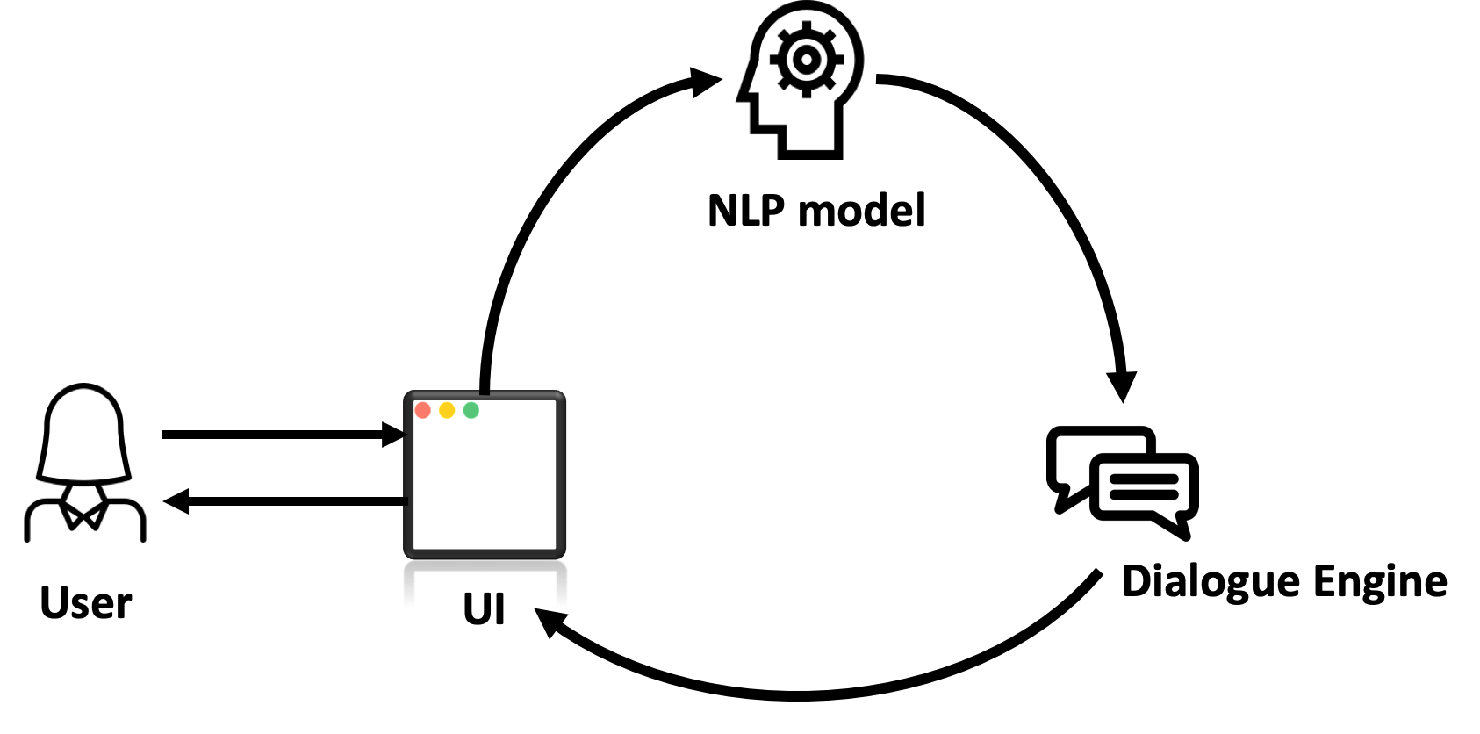

Image 2.1.1: The system block diagram for the technical design.

### 2.1.3 Module-Level descriptions and design (author: Kuan Ying Chern)

The application consists of three main components: a *User Interface*, a *Natural Language Processing Unit*, and a *Dialogue Engine.* This section summarizes the functions of each component of the application and how it connects to each other.

1. **User Interface**

The primary function of this module is to present an aesthetic and intuitive platform for the user to have conversations with the chatbot. It displays a message box for the user to type their messages and a window showing the conversation history with the chatbot. The UI is accessible on the internet and hosted on the web using *Google Firebase.*

The user interface has three parts; first, a landing page for the user to understand the purpose of the application, motivation for the project and what the team hopes users will get out of it as well as information on how and why we are gathering data from their interaction. The second part is the value selection screen which presents a list of value cards the user can use to select the value to discuss. The third part is the chat interface that provides communication between the backend chatbot and the user. Images of the pages are shown in appendix E.

The user interface is responsible for receiving the user’s text and sending it to the next module, which is the NLP unit. It is also responsible for receiving the response from the dialogue engine (more on this in the later sections) and displaying it on the screen. It communicates with these backend modules (which are hosted using an AWS EC2 instance that acts as a https web server) using HTTP REST calls. This is the standard technique to perform POST and GET requests over the internet and provide communication between separate servers.

1. **NLP Unit**

The NLP unit is the module to categorize the user’s messages into one of the specified “intents” as well as extracting the “entities”. Intents are the intention of the text. For example, it could be to *affirm* or to *deny*. The entities are the relevant information from the text.

This module is implemented using an open-source chatbot framework built on Python called “Rasa NLU”. With this framework, the developer team only needed to provide enough training data to the model in order to make it functional. Below are some of the sample intents used in this project and example messages.

Table 2.1.1: some intents used in the project and examples for each intent

|  |  |
| --- | --- |
| Intent | Examples |
| Affirm | * Yes * Indeed * That’s right |
| Deny | * No * I don’t think so * Not really |
| Behaviour_describe | * Singing, exercising, and playing video games * Watching television * Gaming, sleeping, painting |
| Inform | * I think exercising helps improve health because it helps me to build muscles * Because I enjoy playing video games |

As the NLP unit identifies the intent and the entities in the text, it then sends the information to the next module - the dialogue engine, to determine the best response.

1. **Dialogue Engine**

The third module of the project - the Dialogue Engine, is the module that determines the chatbot’s response based on the interpretation of the user’s text given by the NLP unit.

This module, similar to the NLP unit, is built on top of a chatbot framework named “Rasa Core”. With this framework, the developer team needed to provide several listings of the sample conversation, called “stories”. It also required writing several python functions to customize some actions for the chatbot to execute (i.e performing some custom computation based on the information provided by the user). An example of a customized action would be to make sure the user enters three valid activities.

The inputs of this module are from the NLP unit, including the user’s text, its intent and the extracted entities. The dialogue engine sends the best response text back to the UI, so it can be displayed onto the screen for the user to read.

Both the NLP unit and the dialogue engine are considered the backend of the design. They are hosted separately from the frontend since *Firebase* does not support the hosting of a chatbot built on the *Rasa* framework*.* Therefore we use Amazon Web Services (AWS) to host these two modules. These modules are hosted using an AWS T2.2xlarge EC2 instance [28] which acts as a backend https server that the frontend application can communicate with through http REST calls. Additionally, this backend server was set up to use the SSL protocol when communicating with other servers. This ensures that messages sent to and from the backend are encrypted and can’t be read by anyone listening in on the network.

## 2.2 Conversation Design (author: Kuan Ying Chern)

A major portion of this project is the design of the flow of the conversation. It is important since it is the main element used to satisfy the project goal - helping the user to reflect on their behaviour. In this section we will introduce the notion of Motivational Interviewing and how we use it to design the conversation tree.

### 2.2.1 Motivational Interviewing Principles (author: Kuan Ying Chern)

The project is inspired by “Motivational Interviewing” written by W. R. Miller and S. Rollnick [1]. Motivational interviewing (MI) is a technique used by psychologists to help clients gain motivation towards change. One of the important concepts in the book is the four stages of conducting motivational interviewing, which are engaging, focusing, evoking and planning.

In the engaging stage, the interviewer works to set up a trusting relationship with the interviewee and engage them to ensure the smoothness and effectiveness of the entire conversation. Engaging is the process by which both parties establish a helpful connection and a working relationship. The next stage is the focusing stage, this stage is mainly used to scope the topics in the conversation. In the context of this project, this means determining which of the core values they find the most important and the behaviours they would like to change. Within a Motivational Interview, the focusing process helps to clarify direction, the horizon toward which one intends to move. The evoking stage is the stage that elicits the user’s own motivations for change, and it has always been at the heart of Motivational Interviewing. It occurs when there is a focus on a particular change and you harness the user’s own ideas and feelings about why and how they might do it. Lastly, as the client gains motivation from the prior stages, the interviewer moves onto the last stage - planning. The conversation of planning is about action and may cover a large range of topics. It is conducted by discussing plans with the client to invoke the change established by the previous stages. Emphasis is placed on the client’s own solutions and promotes independent decision making.

### 2.2.2 Flowchart of conversation (author: Kuan Ying Chern)

We use the above stages to structure our conversation tree. The following image shows the general structure of the designed conversation tree used by the chatbot as well as how they serve the purpose of the MI stages. It was decided to not include the engaging stage in the conversation since the landing page of the web application is used to serve this purpose. After reading that, the user should know how to use the chatbot as well as what it is trying to accomplish.

1. Focusing

The focusing stage in our project is simple - getting to know what the user values the most, and the activities they spend most of their time on. This scopes the discussion in the later stages, the chatbot will only ask questions about the value the user selected and their opinion on their activities with respect to the value. Below is the flowchart for this stage.

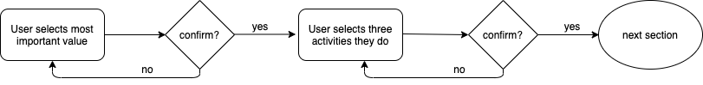

Image 2.2.1: focusing stage of the designed conversation tree.

1. Evoking

In the evoking stage, the bot asks the user how many hours the user spent on each activity they listed in the focusing stage, and then asks them how the activity aligns or does not align with their most important value. The bot then asks them if they should continue doing the activity and why they think that way. The open questions used in this section should help the user to reflect on the particular activity they do.

The bot then moves on to ask about the user’s overall behaviour. This includes asking them if they think their behaviour aligns with the value. The following is the flowchart for this part of the conversation.

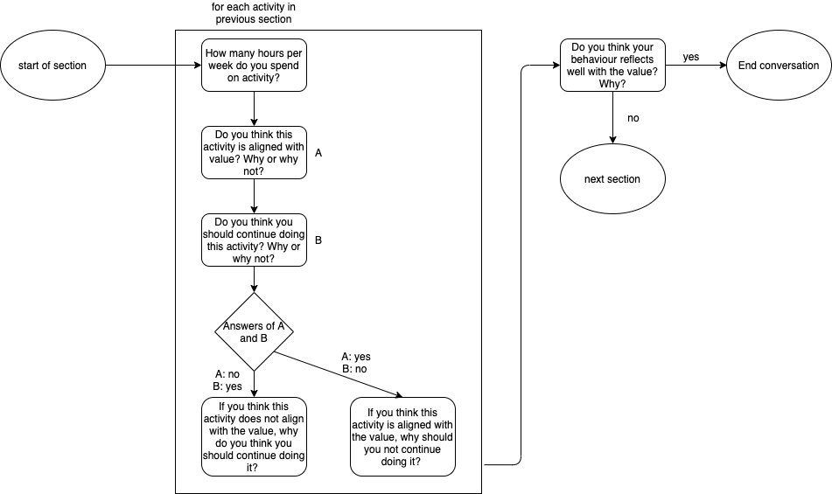

Image 2.2.2: evoking stage of the designed conversation tree

1. Planning

The start of the planning stage will only be triggered if the user does not spend enough time on doing activities that align with the important value or if the user thinks their behaviour does not reflect the value well. The planning stage is also simple, the bot asks the user an activity that will help improve the alignment and commit to do it. Below is the flowchart of the planning stage.

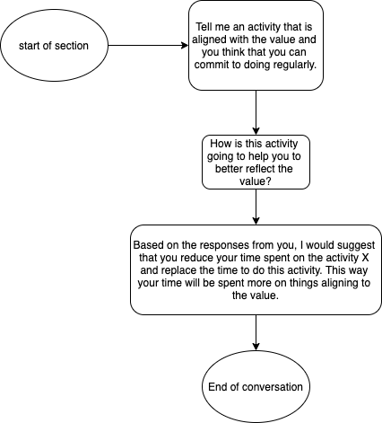

Image 2.2.3: planning stage of the designed conversation tree

## 2.3 Assessment of Final Design (author: Kuan Ying Chern)

This section describes the assessment of the final design. The design is assessed in terms of the web-based user interface, the backend chatbot and the conversation tree in the following subsections.

### 2.3.1 Assessment of web-based user interface (author: Kuan Ying Chern)

Being intuitive and aesthetic for the user and easily distributable are two supporting objectives for this project. To achieve these objectives, it was decided to create a user interface that is hosted online. Below are the advantages and disadvantages of the final user interface

Advantages:

* Ease of access: since the application is hosted on the web, the user only needs a device with internet connection to use the chatbot.
* Intuitive: the user interface provides a clear indication of how to use the software. For example, the page has a text box at the bottom of the page with a submit button below it, this indicates that this is the area in which the user types their message to the chatbot. See appendix E.4 .
* Aesthetics: the user interface also provides aesthetic elements to the application. Without the user interface, the software would be purely console based, which can be very difficult to read. Generally the users think the application has a pleasing user interface as shown in appendix E.

Disadvantages:

* Latency: since the software is hosted on the web, the communications between the servers and the clients would cause a small delay in response time. Although the delays are not long, this is still a disadvantage of using a web based user interface.
* Financial Cost: Though many services (such as Google Firebase) offer free hosting services, these options are limited in what you can host on them. The team had to purchase a hosting service from AWS to host the backend chatbot HTTPS server.

### 2.3.2 Assessment of backend chatbot framework (author: Kuan Ying Chern)

The back-end framework that was chosen to build the chatbot is called Rasa. It is an open-source conversational A.I. framework. This framework is used to implement the NLP unit and the dialogue engine modules described in section 2.1.3. The main reason the team chose to use this framework is because it is free to use, open-source and provides unlimited use. However, the framework also has some disadvantages that caused some delay in the development of the project.   
 Advantages:

* Free to use: Rasa is open-source which also means it is free to use, other frameworks will charge money based on factors such as the number of requests or time spent on the server.
* Unlimited use: Rasa has no restrictions on the number of interactions with the chatbot unlike other chatbot frameworks like DialogFlow.
* Development freedom: Rasa is open-source, which allows developers full access and use of all aspects of Rasa’s code. Other frameworks are blackboxes that do not allow easy customization.

Disadvantages:

* No server: Frameworks such as DialogFlow come with server support that allow them to be easily hosted on the web. Choosing Rasa means that another service to host our chatbot has to be found.
* Fewer Resources: Companies like Google that own frameworks like DialogFlow have access to much more data, which can lead to better trained chatbot models. Foregoing these options means we must find, and preprocess conversation data ourselves.

Since the framework has no server, the team had to find other means to set up servers to host the chatbot backend. In the end, AWS service was chosen to host the chatbot, which costs about 40 cents per hour when the server is on.

### 2.3.3 Assessment of conversation tree (author: Kuan Ying Chern)

The primary function of this project is to guide the user through the process of motivational interviewing to help them reflect on their actions. Based on the user responses, we compiled some positive and negative feedback upon the effectiveness of the conversation.

As shown in Appendix I, most users who tried the chatbot think the conversation with the chatbot helps them realize the discrepancies in their actions and values to some degree. This demonstrates the success of the conversation tree in terms of inflicting reflection in most users. A few users said that the conversation needed more feedback and deeper analysis to be worth the time.

# 

# 3.0 Testing and Verification (author: J. Matthew Chapleau)

## 

## 3.1 Verification Overview (author: J. Matthew Chapleau)

Verification and Acceptance tests for each project requirement are outlined in this section. They are used to measure how well the design fits the requirements and achieves the goal of having users reflect.

**Table 3.1.1 Requirement Verification**

*Note: Our project has a focus on human psychology. As such, some of our requirements can not be assessed as simply a pass or fail. An asterix indicates that the degree of success is subjective to the user. For these entries, please refer to the indicated section or appendix for a more in-depth analysis of verification results.*

|  |  |  |  |  |
| --- | --- | --- | --- | --- |
| **Change?** | **ID** | **Requirement** | **Verification Method** | **Verification Result and Proof** |
| **Modified** | 1.0 | Should direct the user through the Motivational Interviewing process and help them reflect on how their actions express their values. To quantify this, a minimum review score of 4 should be reached, although the emphasis will be placed on analysis of qualitative user feedback. | **Analysis:** The chatbot will ask questions at the end of a session to gauge the effectiveness for the user. This data will be compiled into a user score. A review score of 4 was arrived at through benchmarking with similar chatbots [20][21][22]. However, it was decided that more emphasis will be placed on analysis of user feedback. | Pass*. See section 3.2 for details about the verification method and results. |
|  | 2.0 | Have minimum 75% accuracy [10][11] in interpreting user’s responses using NLP [8]. | **Test:** A validation and test dataset will be constructed separate from the data used to train the NLP algorithm and will be used to test the accuracy via standard machine learning evaluation formulas [23] | Pass. See section 3.3. |
| **Deleted** | ~~3.0~~ | ~~Be 80% accurate [16][10][11] in performing sentiment analysis. [8]~~ | **~~Test:~~** ~~A validation and test dataset will be constructed and will be used to test the accuracy via standard machine learning evaluation formulas [23]~~ | ~~Untested~~ |
|  | 4.0 | Should support a minimum of 15 core values. | **Test:** Direct measurement | Pass. See Appendix D |
|  | 5.0 | Should safely store data from interactions with the user while keeping to guidelines set by the APA [9]. | **Review of Design:** Direct comparison of the chatbot implementation with the guidelines described in the APA record keeping document [9]. | Pass. See section 3.4 |
|  | 6.0 | The implementation shall follow the Personal Information Protection and Electronic Documents Act (PIPEDA) [12]. | **Review of Design:** Direct comparison of the chatbot with PIPEDA to ensure all requirements are adhered to. | Pass. See section 3.4 |
|  | 7.0 | Shall follow research guidelines issued by the University of Toronto [13] | **Review of Design:** Direct comparison of the chatbot design to ensure all interactions with users adhere to the guidelines set by the university. | Pass. See section 3.4 |
|  | 8.0 | Must be a text based chatbot | **Test:** Direct analysis | Pass. See Appendix E. This appendix contains visuals of the final product demonstrating that it is text based. |
|  | 9.0 | Must not contain any offensive language | **Test:** Conversations between users and the chatbot must follow the guidelines set by the University of Toronto’s “Human Resources Guideline on Workplace Harassment and Civil Conduct” [24] | Pass. See Appendix F for a list of questions asked by the chatbot. |
|  | 10.0 | Fast response time | **Test:** Direct measurement. It should take less than 2 second to respond. [14] | Pass. See Appendix G for gathered data on response times. No response time exceeded 1 second. |
|  | 11.0 | Short text response | **Test:** Direct measurement. Each response is between 1 and 5 meaningful sentences with less than 20 words. | Pass. See Appendix H |
| **Modified** | 12.0 | Readability of text | **Test:** Direct measurement using the Flesch–Kincaid readability test [15]. Each text response should have a score of 50 or higher. (i.e. easily understood by people with grade 10-12 education or higher) [15] | Pass. See Appendix H |
|  | 13.0 | Human like | **Test:** Ask users to evaluate how human the chatbot seems at the end of the session. Chatbot will be benchmarked against similar products in the industry. [25] | Fail*. See Appendix I Section 2 for user feedback regarding the chatbot’s speech. |
|  | 14.0 | Intuitive and aesthetically pleasing | **Test:** Ask users to evaluate how intuitive the UI was at the end of the session. Chatbot will be benchmarked against similar products in the industry. [25] Will also follow guidelines set to enhance the readability of the webpage [26]. | Pass*. See Appendix I Section 3. User feedback was positive resulting in an average score of 8.7 out of 10. |
|  | 15.0 | Easily Distributable | **Review of Design:** Access to the chatbot can be easily distributed to the users. | Pass. The chatbot is hosted online at <https://reflection-chatbot-875e4.firebaseapp.com/> |

## 3.2 Verification: Application of Motivational Interviewing (author: J. Matthew Chapleau)

The primary requirement of our project is to direct the user through the Motivational Interviewing process to help users reflect on how their actions express their values. In order to verify whether this requirement was met, real users were asked to interact with the chatbot and fill out a feedback questionnaire afterwards. This questionnaire can be found at the end of Appendix F. A total of 15 users were asked to participate in this initial testing phase and to provide feedback on their experience with the chatbot. Some of these responses are included in Appendix I. This appendix also provides a deeper analysis and summary of the results. For results specific to the application of motivational interviewing, please refer to Appendix I section 1.

The effectiveness of the chatbot in terms of helping users reflect on their values and actions varied between users. Ultimately, the majority of users who interacted with the chatbot found the experience helpful and want to see the chatbot expanded on in the future. Most users found it useful to reflect on what their most important value is and correlate the activities they perform to that value. However, some said that they felt the application needed to offer them more in terms of feedback and individual analysis to make it worth their time.

Many said that it was effective in either reinforcing how they spend their time or helping them to identify what they need to change. The following are quotes from users which express these ideas:

*“In my specific case, [the chatbot] acted as a reinforcement agent. It caused me to really reflect and choose ONE selection up front as to which aspect was MOST important to me. Following that, it caused me to reflect on the actual hours over the last few weeks in terms of time spent and how those aligned with the outcome.”*

*“Yes, it was helpful. I think that it didn’t really give me new insights but it did help me to actually formulate words to describe what I’ve been feeling inside but never really thought about. I felt like I always knew that some of my actions weren’t matching up with my values but this got me to actually confront that. It also helped to actually decide which value was most important to me.”*

To summarize, the chatbot succeeded in helping users to reflect to some degree. However, most users agreed that the experience would be a lot more useful if the chatbot was able to do some of the analysis that a therapist does. For example, being able to probe deeper into certain topics and generate unique feedback and further questions based on the user’s response. The consensus based on user feedback is that there is a lot of potential to AI-powered therapy and while this type of application may never be able to replace a real therapist, it certainly could have a useful role in the future of clinical psychology.

## 3.3 Verification: Natural Language Processing Accuracy (author: J. Matthew Chapleau)

The testing of the natural language processing (NLP) module was divided into two components as there are two main tasks it is used to solve in the application. Testing was divided into activity detection accuracy and ‘inform intent’ detection accuracy. The activity detection was performed by taking a list of the most common activities and hobbies and running them through the activity detection algorithm to see if they are properly identified. The list of activities was augmented with real responses from users as well. The overall accuracy of the activity detection is 78.79%. Refer to Appendix J for details.

The ‘inform intent’ accuracy describes whether the chatbot is correctly able to identify a user’s input as an answer to a question asking the user to explain why/how. These would be responses to the chatbot’s questions such as “You think watching tv is not aligned with physical health, why do you think you should continue watching tv?”. The measured accuracy of the ‘inform intent’ is 82%. Refer to Appendix K for details.

Due to the lack of training and test data, user feedback was also factored into deciding whether the NLP accuracy requirement was met. Most users said that the chatbot understood their responses well (See appendix I) provided they followed the syntax described by the application. Ideally, this syntax would not be necessary. However due to the limited amount of training data available, this was necessary. As more users interact with the bot and more training responses are obtained, this syntax requirement can be eliminated.

## 3.4 Verification: Privacy and Ethics (author: Rajarupan Sampanthan)

A number of security features were implemented to ensure that the privacy and ethics requirements of the project were met. Firstly, the application does not ask for nor store any personal identification information such as name, age, occupation, etc. This helps to ensure confidentiality so that users can feel safe knowing that their responses are completely anonymous. Additionally, the server hosting the backend chatbot has been set up to use SSL connections. This means that when the user’s messages are sent to the server hosting the chatbot, they are encrypted and sent over a secure channel. Thus, their responses cannot be read by anyone listening in on the network.

In addition to making design decisions to ensure application privacy, the project required an ethical review by the University of Toronto’s Ethics Review Committee to ensure that the project met the University’s guidelines. This approval was necessary because the team had to study conversation data between the users and the chatbot to improve the application. The ethics form sent to and approved by the committee is attached to the document under Appendix M. The ethics form details the different aspects about our experiment such as how we selected people to interact with the application, privacy and safety precautions, and compensations for the participants. The Ethics Form was approved by the committee on Wednesday March 11 2019. This can be seen by the signatures signed on the Ethics Form as well as the email correspondence between team member Rajarupan Sampanthan and Professor Jose Zariffa (See Appendix L).

# 4.0 Summary and Conclusion: (author: Shihan Zhang)

As shown by the results in Section 3.0, the chatbot passed all project requirement tests excluding the requirement of being human like. Overall the application was effective in conducting the motivational interview process. Based on user feedback, the majority of users who interacted with the chatbot found the experience helpful and want to see the chatbot be further developed and expanded on in the future. They found it useful to reflect on what their most important value is and correlate the activities performed to that value. Therefore, this process met the needs of the project. However, most users agreed that the experience would be more useful if the chatbot was able to do a more in-depth analysis, similar to one that a therapist would do.

Natural language processing plays an important role in our project. The testing methods include activity detection accuracy and inform intent detection accuracy. The detection accuracy result is 78.79%. This accuracy was obtained from taking a list of activities and running through the chabot to see if they are properly identified. As for ‘inform intent’ accuracy, it identifies a user’s input as an answer to a question asking the user to explain why/how with an accuracy of 82%. The accuracy data meets the goal set in the project requirements, indicating that the chatbot functionality is properly implemented. For ethics, the Ethics and Privacy form had been approved by the University of Toronto’s Ethics Review Committee on Wednesday March 11 2019 and signed by Rajarupan Sampanthan and Professor Jose Zariffa. Thus the safety of user information and confidentiality is guaranteed.

The testing and verification work proved our initial design ideas. As a result, the ultimate project goal is met. However, since our project has a focus on human psychology and some of the test results are based largely on individual users’ feedback, some of our requirements cannot be assessed as simply a pass or fail. Therefore the overall effectiveness is subject to each user’s experience.

The future work of this project should be to keep improving the accuracy of both ‘inform intent’ and activity detection. In order to make the chatbot more human like, one proposed solution is to implement sentiment analysis. These ideas all need more user feedback and testing data for training purposes. Additionally, the chabot could be expanded to act as a virtual therapist and perform a similar analysis to that performed during in-person appointments. This could help people find the reasons for their emotions and actions and make changes according to their values. It can also be integrated with planning or checklist apps related to education, finance and healthcare in order to help people make important decisions correlated to their important values.

**References**

[1] “Reflection critical for self-improvement” *Psychology Today*, 18-Sep-2010. [Online]. Available: [https://www.psychologytoday.com/us/blog/the-social-self/201009/reflection-critical-self-improvemen](https://www.psychologytoday.com/us/blog/the-social-self/201009/reflection-critical-self-improvement)

[2] ”The Importance of Chatbots in Every Business”  *Chatbots Magazine*, 8-Jul-2018. [Online]. Available : <https://chatbotsmagazine.com/the-importance-of-chatbots-in-every-business-infographic-8a8f990be0aa>

[3] ”The computer will see you now” *The Economist* , 20-Aug-2014. [Online]. Available : <https://www.economist.com/science-and-technology/2014/08/20/the-computer-will-see-you-now>

[4] W. R. Miller and S. R. Rollnick, *Motivational interviewing: helping people change*, Third Edition. New York, NY: Guilford Press, 2013.

References for Project Requirements:

[1] W. R. Miller and S. R. Rollnick, *Motivational interviewing: helping people change*, Third Edition. New York, NY: Guilford Press, 2013.

[2] “Chatbot Market To Reach USD 10.08 Billion By 2026: Reports And Data,” *GlobeNewswire News Room*, 26-Aug-2019. [Online]. Available: <https://www.globenewswire.com/news-release/2019/08/26/1906677/0/en/Chatbot-Market-To-Reach-USD-10-08-Billion-By-2026-Reports-And-Data.html>.

[3] “The computer will see you now,” *The Economist*, 20-Aug-2014. [Online]. Available: <https://www.economist.com/science-and-technology/2014/08/20/the-computer-will-see-you-now>

[4] L. Kim, “The Importance of Chatbots in Every Business (Infographic),” *Medium*, 08-Jun-2018. [Online]. Available: <https://chatbotsmagazine.com/the-importance-of-chatbots-in-every-business-infographic-8a8f990be0aa>.

[5] E. Ortiz-Ospina and M. Roser, “Happiness and Life Satisfaction,” *Our World in Data*, 14-May-2013. [Online]. Available: <https://ourworldindata.org/happiness-and-life-satisfaction>.

[6] W. Wang, J. Li, G. Sun, and X.-an Z. Zhiming Cheng, “Achievement goals and life satisfaction: the mediating role of perception of successful agency and the moderating role of emotion reappraisal,” *SpringerLink*, 22-Dec-2017. [Online]. Available: <https://link.springer.com/article/10.1186/s41155-017-0078-4>.

[7] A. R. McConnel, “Reflection critical for self-improvement,” *Psychology Today*, 18-Sep-2010. [Online]. Available: <https://www.psychologytoday.com/us/blog/the-social-self/201009/reflection-critical-self-improvement>.

[8] K. P. Shung, “Accuracy, Precision, Recall or F1?,” *Medium*, 08-Jun-2018. [Online]. Available: <https://towardsdatascience.com/accuracy-precision-recall-or-f1-331fb37c5cb9>.

[9] “Record Keeping Guidelines.,” *American Psychologist*, vol. 62, no. 9, pp. 993–1004, Dec. 2007.

( <https://www.apa.org/pubs/journals/features/record-keeping.pdf>)

[10] D. Leroy, “Benchmarking Natural Language Understanding Systems,” *Medium*, 25-Jul-2017. [Online]. Available: <https://medium.com/snips-ai/benchmarking-natural-language-understanding-systems-d35be6ce568d>.

[11] S. A. Ellafi, “Comparing production-grade NLP libraries: Accuracy, performance, and scalability,” *O'Reilly Media*, 28-Feb-2018. [Online]. Available: <https://www.oreilly.com/ideas/comparing-production-grade-nlp-libraries-accuracy-performance-and-scalability>.

[12] Loc.gov. (2012). *Online Privacy Law: Canada | Law Library of Congress*. [online] Available at: <https://www.loc.gov/law/help/online-privacy-law/2012/canada.php>.

[13] Onesearch.library.utoronto.ca. *Research Data Management*. [online] Available at: <https://onesearch.library.utoronto.ca/researchdata>.

[14] F. F.-H. Nah, "A study on tolerable waiting time: How long are Web users willing to wait?", *J. Beh. Inf. Technol.*, vol. 23, no. 3, pp. 153-163, 2004.

[15] Flesch, Rudolf. "How to Write Plain English". University of Canterbury. [online] Available at: <https://web.archive.org/web/20160712094308/http://www.mang.canterbury.ac.nz/writing_guide/writing/flesch.shtml>.

[16] “Sentiment analysis,” *NLP*. [Online]. Available: <http://nlpprogress.com/english/sentiment_analysis.html>.

[17] V. Batanović, B. Nikolić, and M. Milosavljević, “Reliable Baselines for Sentiment Analysis in Resource-Limited Languages: The Serbian Movie Review Dataset,” *Reliable Baselines for Sentiment Analysis in Resource-Limited Languages: The Serbian Movie Review Dataset*, 2016.

[18] S. Li, “Multi-Class Text Classification Model Comparison and Selection,” *Medium*, 06-Dec-2018. [Online]. Available: <https://towardsdatascience.com/multi-class-text-classification-model-comparison-and-selection-5eb066197568>.

[19] D. L. Mccollum, “What Are the Social Values of College Students?: A Social Goals Approach,” *Journal of College and Character*, vol. 6, no. 6, Sep. 2005.

[20] D. Browne, M. Slozberg, and M. Arthur, “Do Mental Health Chatbots Work?,” *healthline*, 06-Jul-2018. [Online]. Available: <https://www.healthline.com/health/mental-health/chatbots-reviews>.

[21] “Woebot: Your Self-Care Expert - Apps on Google Play,” *Google*. [Online]. Available: <https://play.google.com/store/apps/details?id=com.woebot&hl=en>.

[22] “Wysa: stress, depression & anxiety therapy chatbot – Apps on Google Play,” *Google*. [Online]. Available: <https://play.google.com/store/apps/details?id=bot.touchkin&hl=en_CA>.

[23] A. Guanga, “Understand Classification Performance Metrics,” *Medium*, 19-Oct-2018. [Online]. Available: <https://becominghuman.ai/understand-classification-performance-metrics-cad56f2da3aa>.

[24] “HUMAN RESOURCES GUIDELINE ON WORKPLACE HARASSMENT AND CIVIL CONDUCT (‘CIVILITY GUIDELINE’),” *University of Toronto*, 30-Nov-2018. [Online]. Available: <http://policies.hrandequity.utoronto.ca/wp-content/uploads/sites/34/2016/09/Human-Resources-Guideline-on-Workplace-Harassment-and-Civil-Conduct-Civ....pdf>.

[25] “10 Best Chatbots of 2020,” *Consumers Advocate*, 27-Nov-2019. [Online]. Available: <https://www.consumersadvocate.org/chatbots/a/best-chatbots?pd=true&keyword=chatbot&gca_campaignid=1268730917&gca_adgroupid=52791084643&gca_matchtype=p&gca_network=g&gca_device=c&gca_adposition=1t1&gca_loc_interest_ms=&gca_loc_physical_ms=9061009&&pd=true&keyword=chatbot&gca_campaignid=1268730917&gca_adgroupid=52791084643&gca_matchtype=p&gca_network=g&gca_device=c&gca_adposition=1t1&gca_loc_interest_ms=&gca_loc_physical_ms=9061009&gclid=Cj0KCQjwivbsBRDsARIsADyISJ-OhqLrsZJeWy7nknebyezEd1APVeT1Pk_l_HNZNpzVKuPdFxmEobYaAnU5EALw_wcB>.

[26] “How to Meet WCAG (Quick Reference),” *How to Meet WCAG (Quickref Reference)*, 04-Oct-2019. [Online]. Available: <https://www.w3.org/WAI/WCAG21/quickref/#distinguishable>.

[27] T. Mackenzie, “App store fees, percentages, and payouts: What developers need to know,” *TechRepublic*, 12-Jul-2018. [Online]. Available: <https://www.techrepublic.com/blog/software-engineer/app-store-fees-percentages-and-payouts-what-developers-need-to-know/>.

[28] “Amazon EC2 Instance Types,” *Amazon*. [Online]. Available: <https://aws.amazon.com/ec2/instance-types/>

# Appendix A: Gantt Chart History

**Final Project Proposal (oldest)**

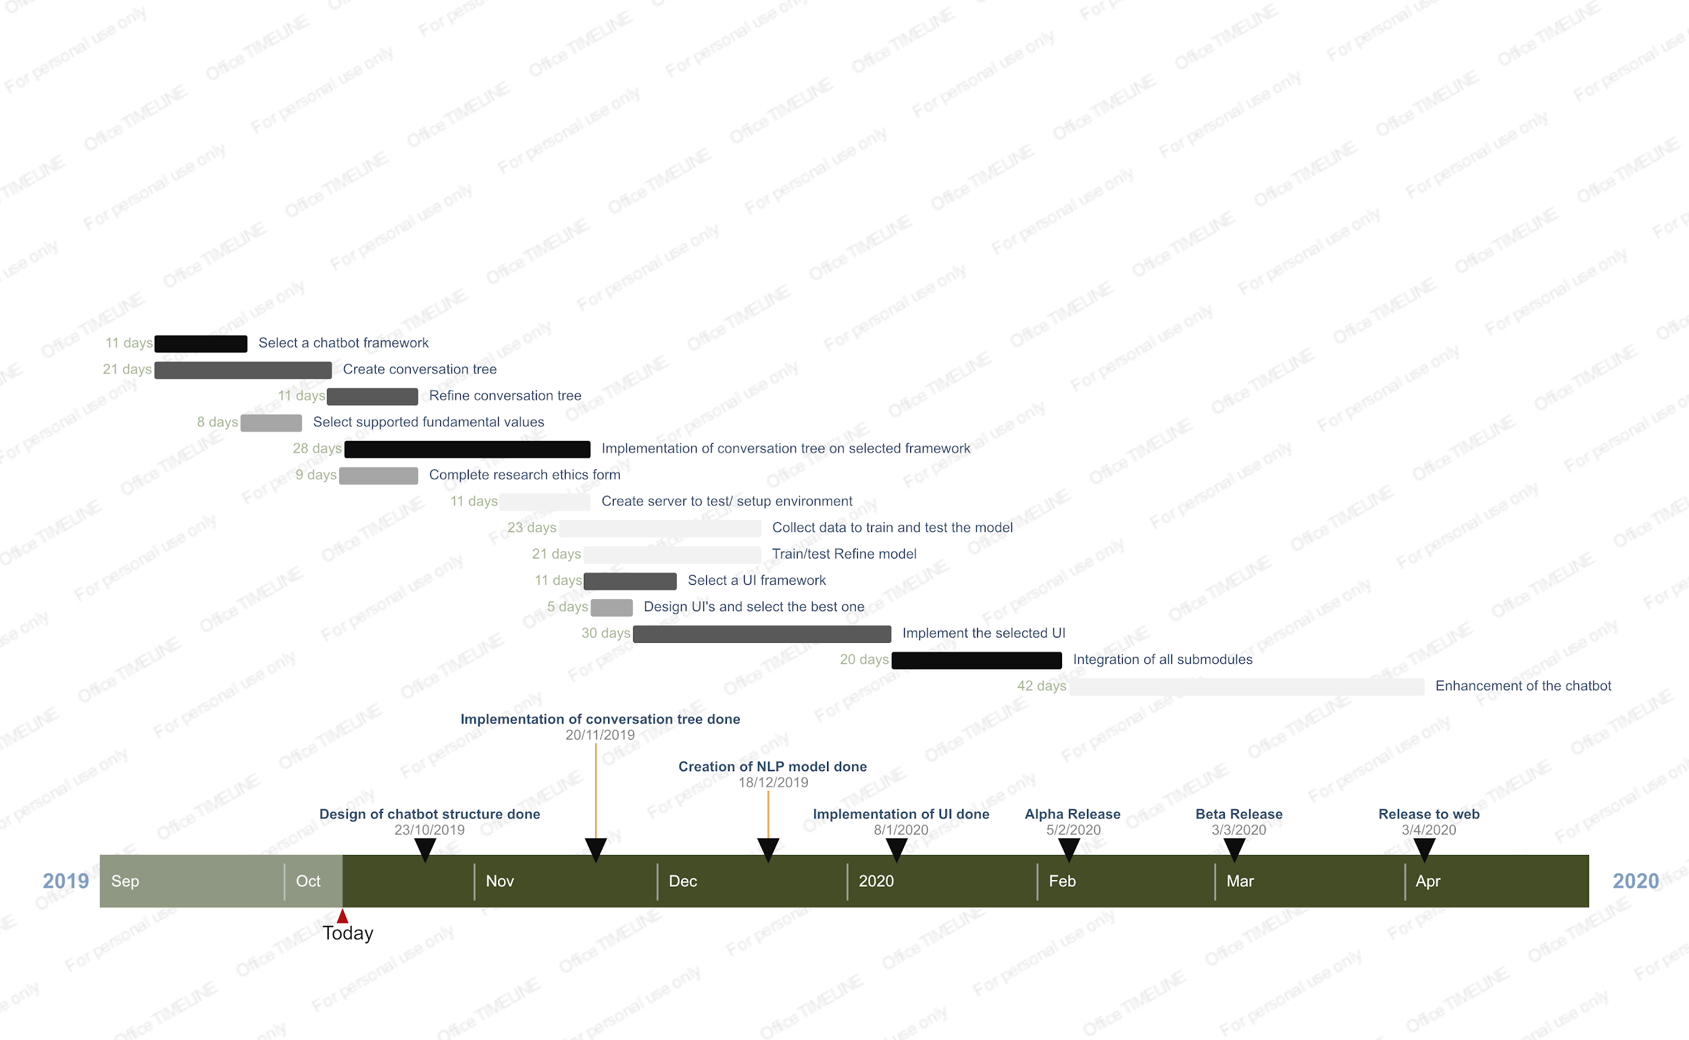

**Progress Report (newest)**

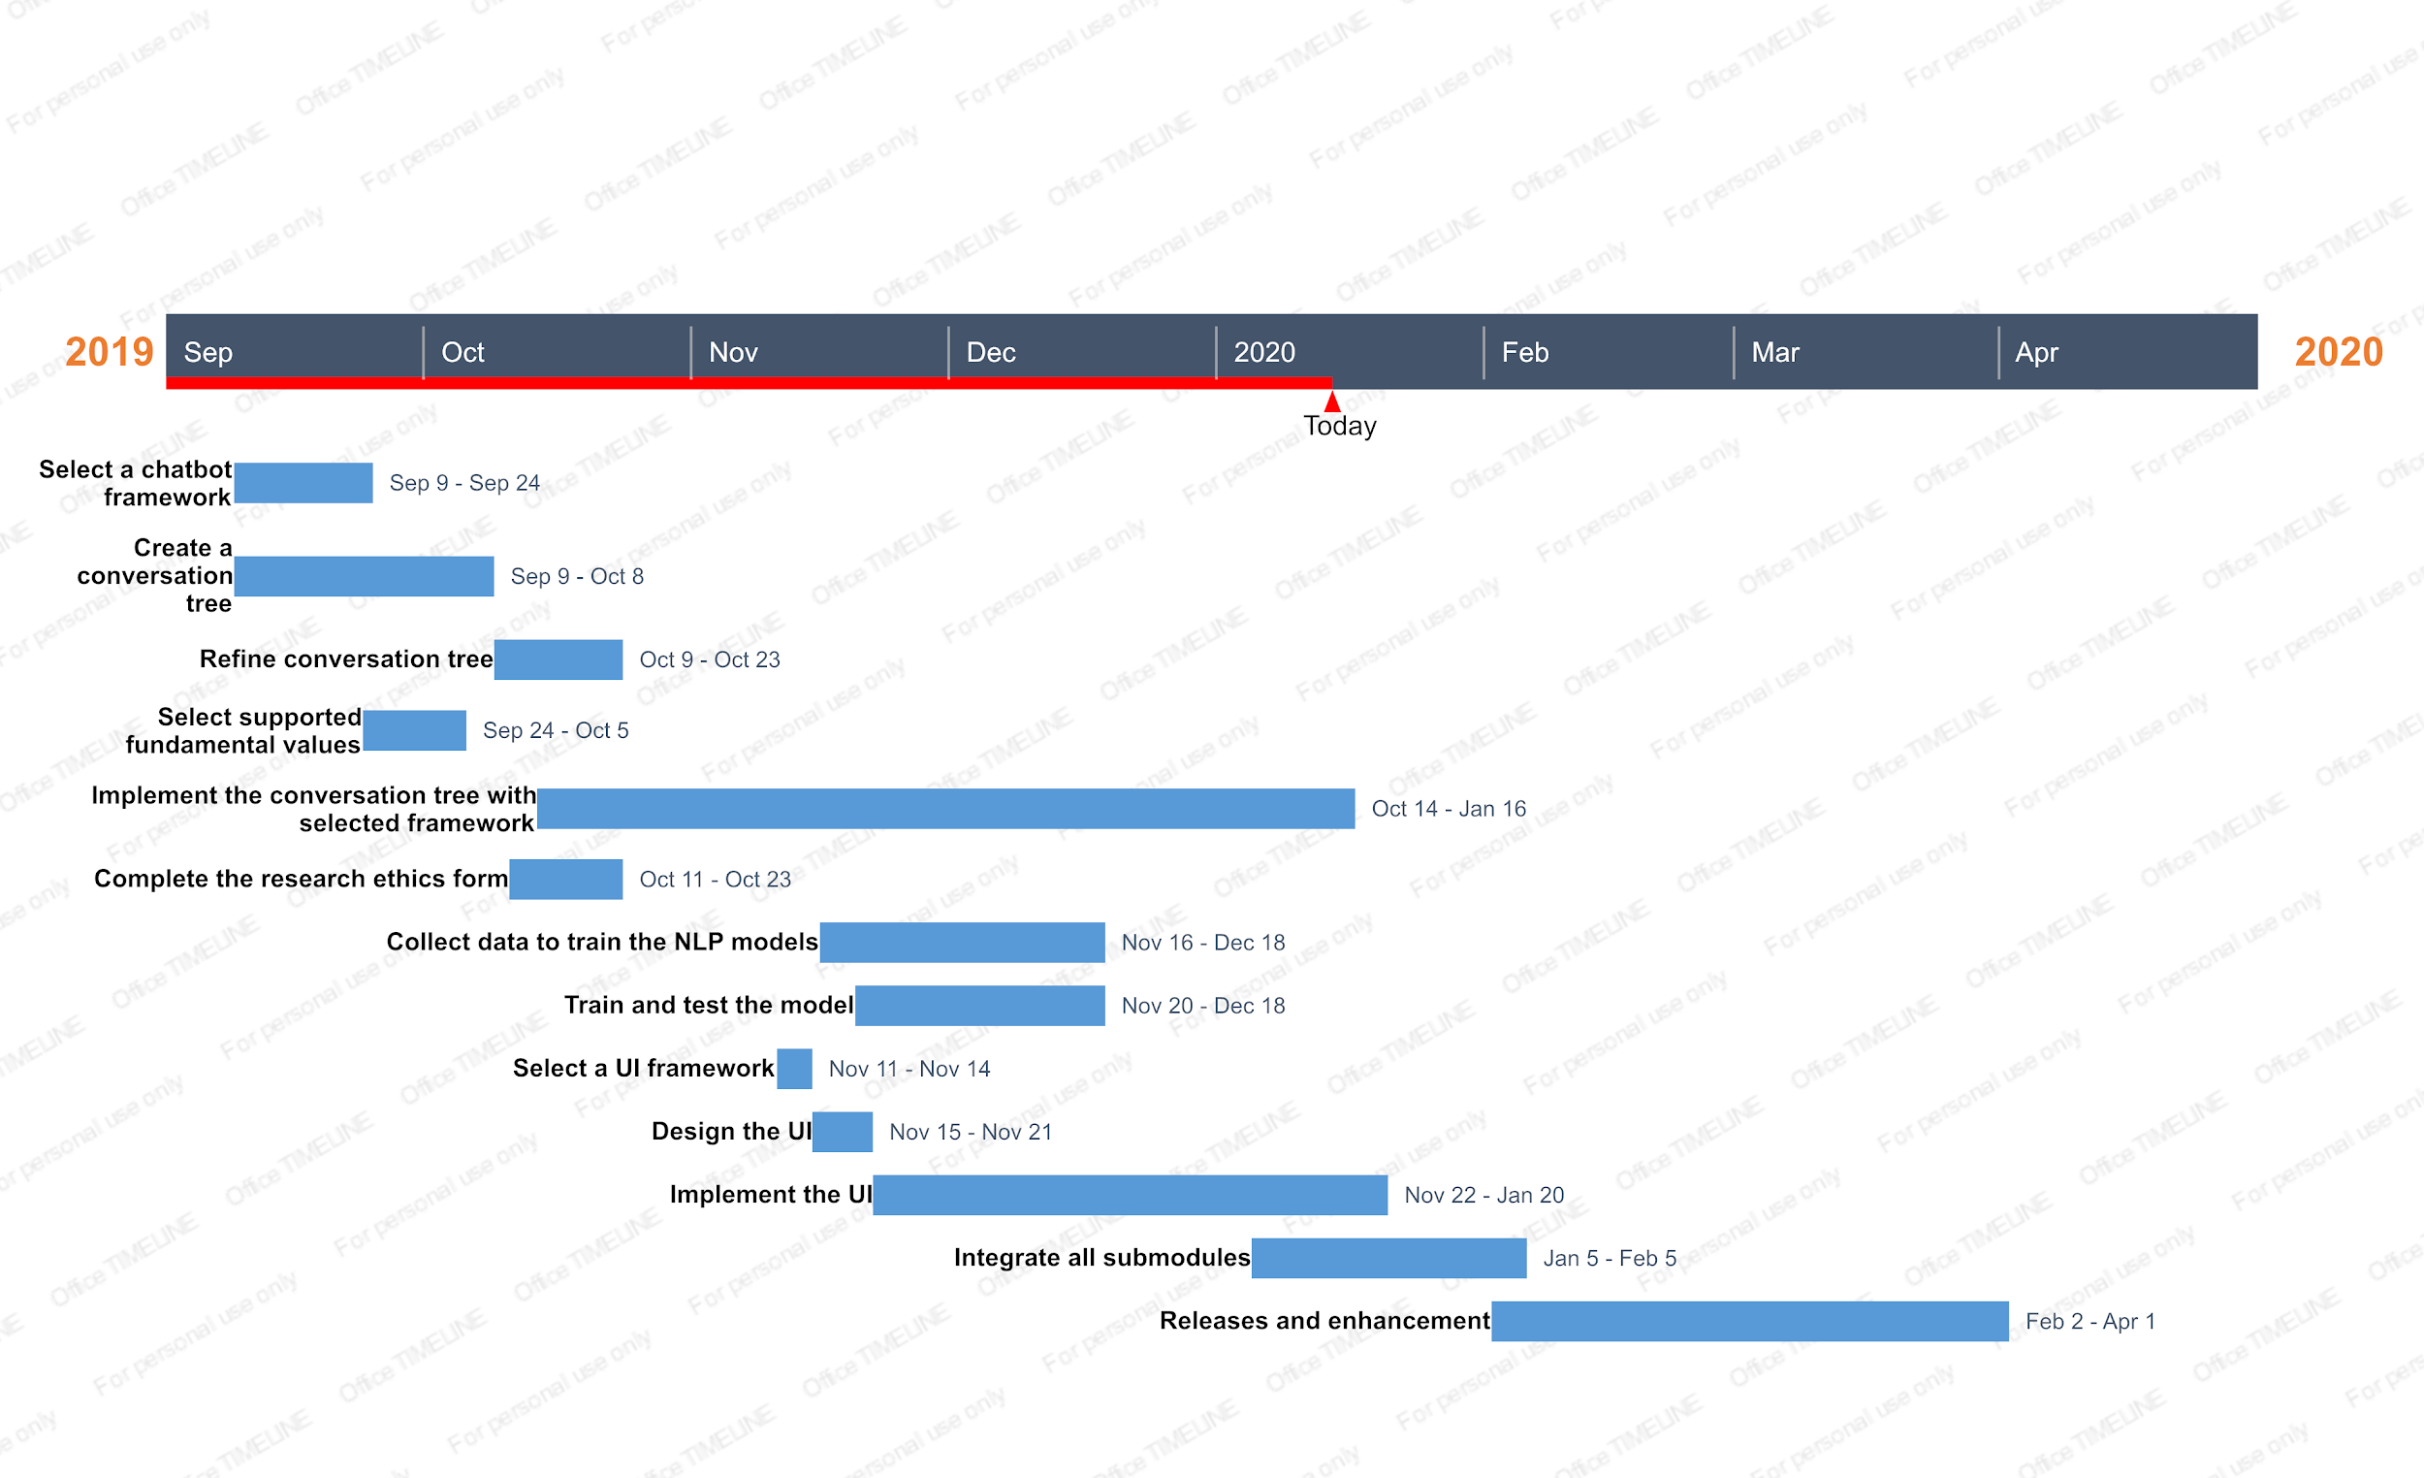

# Appendix B: Financial Plan

The budget and the estimation of required funding is summarized in the Table below.

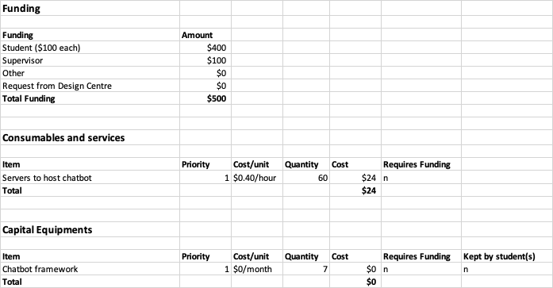

The total available funding is $500.00, with $100.00 from each team member and $100.00 from the supervisor.

We estimate that we will activate AWS server to host the chatbot backend about 2 hours a day for a month. That leads to a total of 60 hours, and it costs 40 cents per hour it is activated, thus the total cost for hosting the chatbot is $24.

The Cost of Manpower is estimated to be $20 per person-hour. Each developer will spend about 8 hours per week for 25 weeks, there are 4 developers for this software. Thus the cost of manpower is about $16,000 in total. However, this cost will be ignored for this project, since the engineering team does not charge for working on this project.

# Appendix C: Validation and Acceptance Tests

|  |  |  |
| --- | --- | --- |
| **ID** | **Project Requirement** | **Verification Method** |
| 1.0 | Should direct the user through the motivational interviewing process and help them reflect on how their actions express their values. To quantify this, a minimum review score of 4 should be reached. | **Test:** The chatbot will ask questions at the end of a session to gauge the effectiveness for the user. This data will be compiled into a user score. A review score of 4 was arrived at through benchmarking with similar chatbots. [20][21][22] |
| 2.0 | Have minimum 75% accuracy [10][11] in interpreting user’s responses using NLP [8]. | **Test:** A validation and test dataset will be constructed separate from the data used to train the NLP algorithm and will be used to test the accuracy via standard machine learning evaluation formulas [23] |
| 3.0 | Be 80% accurate [16][10][11] in performing sentiment analysis. [8] | **Test:** A validation and test dataset will be constructed and will be used to test the accuracy via standard machine learning evaluation formulas [23] |
| 4.0 | Should support a minimum of 15 core values. | **Test:** Direct measurement |
| 5.0 | Should safely store data from interactions with the user while keeping to guidelines set by the APA [9]. | **Review of Design:** Direct comparison of the chatbot implementation with the guidelines described in the APA record keeping document [9]. |
| 6.0 | The implementation shall follow the Personal Information Protection and Electronic Documents Act (PIPEDA) [12]. | **Review of Design:** Direct comparison of the chatbot with PIPEDA to ensure all requirements are adhered to. |
| 7.0 | Shall follow research guidelines issued by the University of Toronto [13] | **Review of Design:** Direct comparison of the chatbot design to ensure all interactions with users adhere to the guidelines set by the university. |
| 8.0 | Must be a text based chatbot | **Test:** Direct analysis |
| 9.0 | Must not contain any offensive language | **Test:** Conversations between users and the chatbot must follow the guidelines set by the University of Toronto’s “Human Resources Guideline on Workplace Harassment and Civil Conduct” [24] |
| 10.0 | Fast response time | **Test:** Direct measurement. It should take less than 2 second to respond. [14] |
| 11.0 | Short text response | **Test:** Direct measurement. Each response is between 1 and 5 meaningful sentences with less than 20 words. |
| 12.0 | Readability of text | **Test:** Direct measurement using the Flesch–Kincaid readability test [15]. Each text response should have a score of 70 or higher. |
| 13.0 | Human like | **Test:** Ask user to evaluate how human the chatbot seems at the end of the session. Chatbot will be benchmarked against similar products in the industry. [25] |
| 14.0 | Intuitive and aesthetically pleasing | **Test:** Ask user to evaluate how intuitive the UI was at the end of the session. Chatbot will be benchmarked against similar products in the industry. [25] Will also follow guidelines set to enhance the readability of the webpage [26]. |
| 15.0 | Easily Distributable | **Review of Design:** Access to the chatbot can be easily distributed to the users. |

**Changes:**

There were three notable changes made to the validation and acceptance tests. First, for project requirement 1.0, it was decided that more emphasis would be placed on the analysis of user feedback rather than on a cumulative user score. This was chosen because due to time constraints, only a few users were able to test the chatbot and provide feedback. Having only a few users meant that the review score was easily skewed by outlier ratings and thus was not a good reflection of the actual success of the design. Thus more emphasis was placed on the comments made by users and the analysis of those comments in relation to the project goal.

Secondly, the test for project requirement 3.0 was removed. Due to time constraints, the team was not able to implement sentiment analysis into the design.

Lastly, the score for the readability of text was lowered to 50.0 or greater. Based on the flesch-kincaid readability test, a score of 50.0 - 60.0 means that it should be easily understood by people with grade 10 - 12 education or higher. Since the target audience is undergraduate students, this score is more appropriate than the initial goal of 70.0 or greater (which would correspond to being easily understood by people with at least grade 7 education).

# Appendix D: Value List

1. **Achievement** - to have important accomplishments

2. **Family** - to have a happy, loving family

3. **Fun/Adventure** - to play and have fun; to have new and exciting experiences

4. **Physical Health** - to be physically well and healthy

5. **Mindfulness/** **Mental Health** - to be mentally well and healthy

6. **Independence** - to be free from depending on others

7. **Purpose** - to have meaning and direction in my life

8. **Self-esteem** - to feel good about myself

9. **Wealth** - to have plenty of money

10. **Friendship** - to have close, supportive friends

11. **Virtue /** **Morality** - to live a morally pure and excellent life

12. **Romance** - to have intense, exciting love in my life

13. **Responsibility** - to make and carry out responsible decisions

14. **Knowledge** - to learn and contribute valuable knowledge

15. **Acceptance** - to be accepted as I am

# Appendix E: Visuals of the Final Product

**Figure E.1: Landing Page**

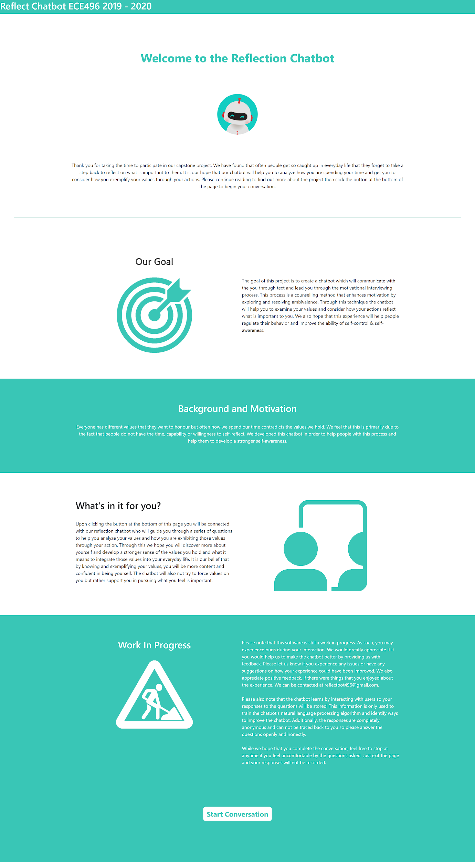

**Figure E.2: Consent Form**

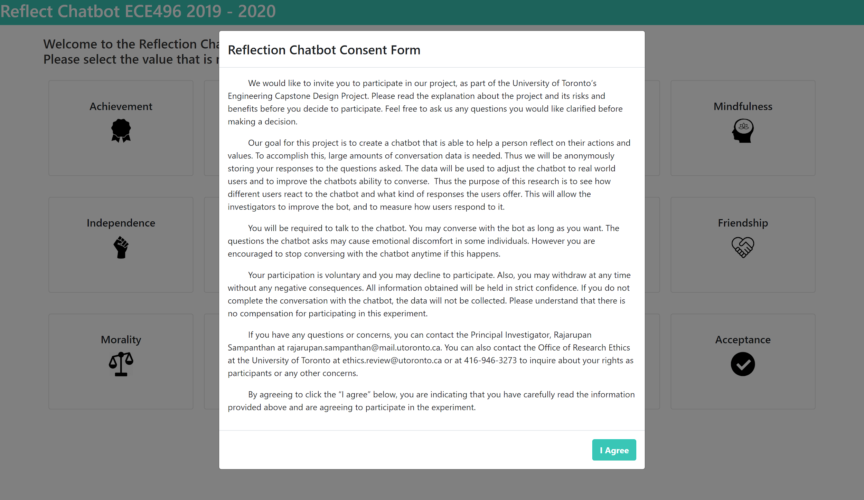

**Figure E.3: Value Selection Screen**

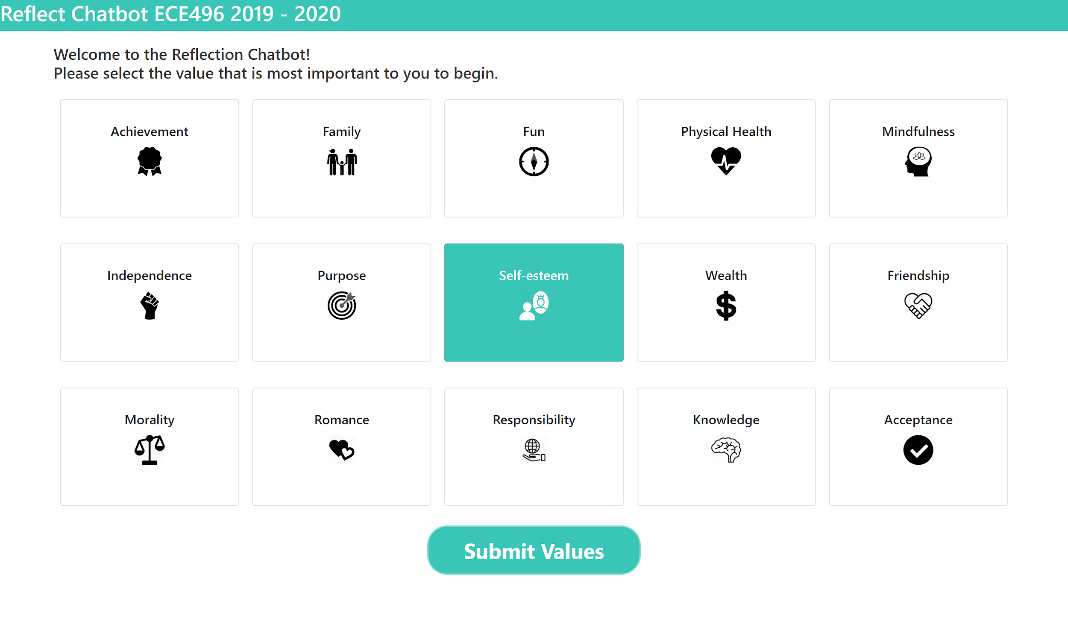

**Figure E.4: Conversation Screen**

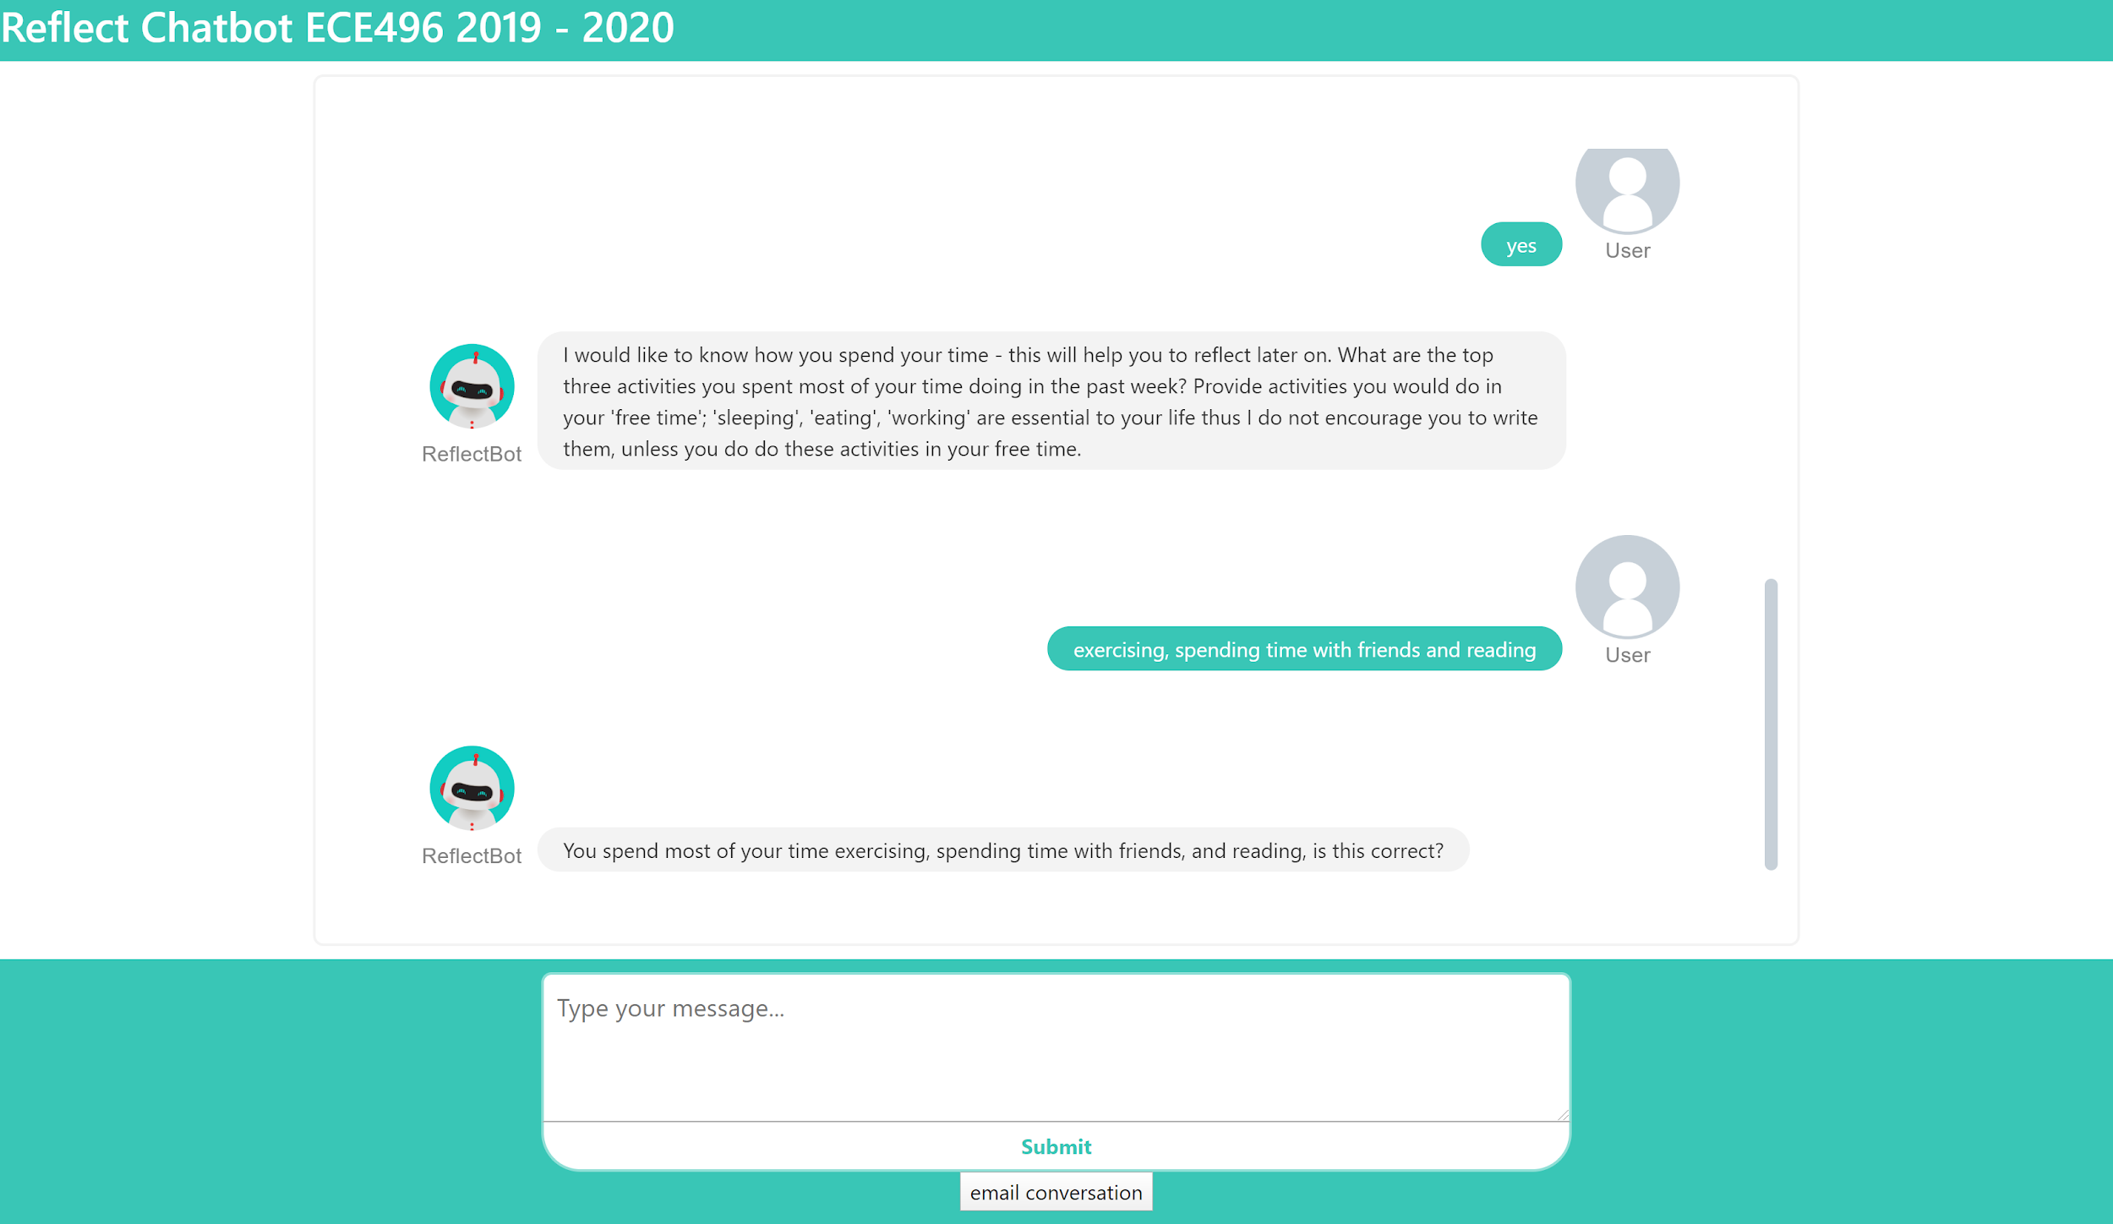

# Appendix F: Structured Questionnaire

**Focusing stage**

* "Select the most important value"
  + You think {value} is the most important value to you, correct?
* I would like to know how you spend your time - this will help you to reflect later on. What are the top three activities you spent most of your time doing in the past few months? Provide activities you would do in your 'free time'; 'sleeping', 'eating', and 'working' is essential to your life thus I do not encourage you to write them unless you do these activities in your free time.
  + "confirm"

**Evoking stage**

* For each activity:
  + How many hours per week do you spend time on this activity?
  + Do you think this activity is aligned with {value}? if not, why?
  + Do you think you should continue doing this activity? - Why?
* After all three activities:
  + Other than the three activities you mentioned, do you spend time on activities that are also aligned with {value}? Please enter the total number of hours per week you spend on them. (Enter 0 if none)
  + if total hours < 1 hour, go to **plan stage**
  + Do you think your behaviour reflects the value well?
    - if not, go to **plan stage**
    - if yes - Good! I hope you maintain your behaviour that reflects well with {value}! **END**

**Plan stage**

* Tell me an activity that is aligned with {value} and you think that you can commit to doing regularly.
* How is this activity going to help you to better reflect {value}?
* Based on the responses from you, I would suggest that you reduce your time spent on {activity that does not align and should not be continued} and replace the time to do this activity. This way your time will be spent more on things aligning to {value}.

**End**

* That's the end of this conversation! I hope the session helps you to reflect on your actions and your most important value! Please send us any feedback via {insert email address}.

**Questions for users:**

1. How do you feel after speaking with the chatbot and answering these questions? Did you find it helpful? Did you feel comfortable answering the questions, etc.?
2. Did you find the conversation helpful? If yes, how so? If not, why not?
3. Did it help you to align your actions and values? Did it help you to identify any discrepancies?
4. how would you rate the chatbot out of 10 in regards to helping you align actions and values?
5. How did you feel while talking to the chatbot? Did you enjoy the conversation?
6. Did the chatbot feel human like?
7. How would you compare it to speaking with a therapist? Are there things you liked better? Are there things that you feel were worse?
8. How well do you feel the chatbot understood your inputs?
9. How would you rate the chatbot's speech in regards to being human like (out of 10)?
10. Did you enjoy the aesthetics of the chatbot and the supporting web application? Did you enjoy the user experience? Is there anything you didn't like? If you wouldn't mind, please give it a rating out of 10 as well as providing general feedback.
11. Any other comments you would like to add? Things you liked, didn't like?

# Appendix G: Data on Response Times

The following response time data was collected during user interactions with the chatbot. The response time measures the time from when the user sends their message until the chatbots response message is displayed on the screen. Data was collected over 5 different user interactions. These interactions were completed on different wifi connections and used a variety of browsers including Chrome, Firefox and Microsoft Edge.

As seen from the data all response times are well below our requirement of a maximum 2 second response time.

*Note1: For brevity, only a subset of the response time data gathered is included below. However, the data provided covers multiple browsers across different network connections and features varying request and response sizes. Therefore it is a good representation of the response time data as a whole. It was collected during interactions with real users.

*Note2: ‘https://reflectchatbotece496.xyz/’ is the backend server, hosting our chatbot algorithm. The front end communicates with this via REST calls.

**Table G.1 Response time of POST requests to ‘https://reflectchatbotece496.xyz/’**

|  |  |  |
| --- | --- | --- |
| **Response Time (ms)** | **Request Size (bytes)** | **Response Size (bytes)** |
| 332 | 702 | 422 |
| 231 | 699 | 888 |
| 401 | 725 | 459 |
| 365 | 699 | 684 |
| 289 | 703 | 426 |
| 248 | 699 | 423 |
| 264 | 698 | 460 |
| 286 | 739 | 420 |
| 302 | 699 | 471 |
| 314 | 788 | 602 |
| 319 | 704 | 427 |
| 269 | 699 | 423 |
| 566 | 699 | 442 |
| 250 | 719 | 420 |
| 370 | 699 | 334 |
| 301 | 699 | 626 |
| 422 | 698 | 431 |
| 260 | 699 | 427 |
| 291 | 698 | 446 |
| 466 | 721 | 424 |
| 375 | 699 | 769 |
| 329 | 697 | 569 |
| 664 | 703 | 423 |
| 227 | 699 | 888 |
| 297 | 731 | 462 |
| 305 | 699 | 693 |
| 241 | 698 | 431 |
| 300 | 699 | 428 |
| 291 | 698 | 469 |
| 239 | 936 | 424 |
| 405 | 699 | 480 |
| 316 | 923 | 610 |
| 323 | 698 | 431 |
| 452 | 699 | 428 |
| 369 | 698 | 469 |
| 298 | 771 | 424 |
| 436 | 698 | 605 |
| 260 | 698 | 426 |
| 359 | 699 | 423 |
| 360 | 699 | 442 |
| 288 | 786 | 419 |
| 365 | 699 | 770 |
| 650 | 697 | 571 |
| 300 | 698 | 606 |
| 334 | 706 | 449 |
| 307 | 952 | 909 |

# Appendix H: Readability Analytics

The following statistics were generated using the Flesch Kincaid readability test. In our requirements we aimed to achieve a Flesch Kincaid Reading Ease score of above 50.0 for each message. A score of 50.0 - 60.0 indicates that the text is easily understood by people with at least grade 10-12 education [15]. Since our target users are undergraduate students this score is acceptable. As seen by the statistics below, all messages sent by the chatbot meet this requirement. The following web application was used to generate the results: <https://www.webfx.com/tools/read-able/check.php>

*Note: the actual messages used by the chatbot substitute the value and activity being discussed into the messages. Therefore the scores of the text used in a given interaction may differ slightly though should be comparable.

Q1. Welcome to the Reflection Chatbot! Please select the value that is most important to you to begin.

Stats:

Flesch Kincaid Reading Ease 68.8

Flesch Kincaid Grade Level 5.8

No. of sentences 2

No. of words 17

Q2: I would like to know how you spend your time - this will help you to reflect later on. What are the top three activities you spent most of your time doing in the past few months? Provide activities you would do in your 'free time'; 'sleeping', 'eating', and 'working' is essential to your life thus I do not encourage you to write them unless you do these activities in your free time.

Stats:

Flesch Kincaid Reading Ease 74.4

Flesch Kincaid Grade Level 8.8

No. of sentences 3

No. of words 72

Q3: On average, how many hours do you spend time on exercising in a week?

*”Exercising” was chosen as the activity. Other activities should have a similar score.

Stats:

Flesch Kincaid Reading Ease 77.8

Flesch Kincaid Grade Level 5.9

No. of sentences 1

No. of words 14

Q4: Do you think exercising is aligned with Family?

*”Exercising” and “Family” were chosen as the activity and value. Other activity-value pairs should have a similar score

Stats:

Flesch Kincaid Reading Ease 50.7

Flesch Kincaid Grade Level 8.2

No. of sentences 1

No. of words 8

Q5: You believe exercising does not align with Family, why do you spend time on exercising?

Stats:

Flesch Kincaid Reading Ease 50.6

Flesch Kincaid Grade Level 9.9

No. of sentences 1

No. of words 15

Q6: Do you think you should continue doing this activity? Why?

Stats:

Flesch Kincaid Reading Ease 66.4

Flesch Kincaid Grade Level 5.2

No. of sentences 2

No. of words 10

Q7: Other than the three activities you mentioned, do you spend time on activities that are also aligned with this value? Please enter the total number of hours per week you spend on them. (Enter 0 if none)

Stats:

Flesch Kincaid Reading Ease 75.4

Flesch Kincaid Grade Level 5.8

No. of sentences 3

No. of words 37

Q8: Do you think your behaviour reflects the value well?

Stats:

Flesch Kincaid Reading Ease 66.1

Flesch Kincaid Grade Level 6.3

No. of sentences 1

No. of words 9

Q9: Tell me an activity that is aligned with this value that you think you can commit to doing regularly.

Stats:

Flesch Kincaid Reading Ease 58.4

Flesch Kincaid Grade Level 9.8

No. of sentences 1

No. of words 19

Q10: How is this activity going to help you to better reflect the value?

Stats:

Flesch Kincaid Reading Ease 63.5

Flesch Kincaid Grade Level 7.6

No. of sentences 1

No. of words 13

Q11: Based on the responses from you, I would suggest that you reduce your time spent on activity 1 and replace the time to do this activity. This way your time will be spent more on things aligning to your value.

Stats:

Flesch Kincaid Reading Ease 76.6

Flesch Kincaid Grade Level 7.6

No. of sentences 2

No. of words 40

# Appendix I: User Feedback Analysis

The following responses are from real users who have interacted with the chatbot. This section is divided into subsections which identify what aspects of the project the feedback relates to. While 15 users tested the application, only 7 feedback questionnaires are included in this appendix. Some testers preferred not to fill out the questionnaire and gave unstructured feedback to members of the team. These are not included below but cover similar ideas expressed in the ones that are provided.

**Section 1: Application of Motivational Interviewing Process**

This section deals with whether users felt that the chatbot was helpful in getting them to reflect on their values and actions.

The results for this section varied from person to person. There were many who found the exercise helpful but some found that the application did not offer them enough to make it worth their time. However, almost everyone agreed that there is a lot of potential to this and would like to see improvements made in the future. The main concern raised was that the chatbot did not probe far enough into topics. Many users would like to see the chatbot be able to understand their responses to a deeper level and provide insights and feedback, similar to what a therapist does. Right now the chatbot is only able to identify the general intent of a user’s response and identify activities.

Users also said that they would like to see the chatbot cover more than just one value. From the results, it seemed that most users had their actions aligned with their most important value. However, perhaps if we looked at their top 3, we might find more discrepancies between values and actions.

On average, users said that they would give the chatbot 7/10 in terms of helping them align their values and actions.

1. ***How do you feel after speaking with the chatbot and answering these questions? Did you find it helpful? Did you feel comfortable answering the questions, etc.?***

|  |  |
| --- | --- |
| *User 1* | *“I felt like the questions were very easy to answer and were very clear. I thought the first question was a little bit harder because it is hard to pick just one thing to value. Some people might not know what they value so a quiz/questionnaire to determine that might be a little bit easier.”* |
| *User 2* | *“I found it easy to answer the questions, they were clear and specific. It was non-threatening speaking to the chatbox instead of a person. No judgement.”* |
| *User 3* | *“I felt fine answering the questions, though through my experience i didn't really feel like my answers were not really going anywhere, like there is potential, but its just not there yet.”* |
| *User 4* | *“Yes, it was helpful. I think that it didn’t really give me new insights but it did help me to actually formulate words to describe what I’ve been feeling inside but never really thought about. I felt like I always knew that some of my actions weren’t matching up with my values but this got me to actually confront that. It also helped to actually decide which value was most important to me.”* |
| *User 5* | *“It’s pretty cool, quite helpful for reflecting personal values. The webapp design makes it comfortable to use too.”* |
| *User 6* | *“It feels comfortable but not helpful. I know what my values are and what I supposed to do. I just can’t control myself”* |
| *User 7* | *“I think the chatbot got me to reflect on THE most important element for me up front. This was a tough choice as I value family, health, achievement and others very highly.*  *It was helpful as it then asked me to identify hours spent on this. I think this is a valuable way to either reinforce current behaviour…. Or to highlight where ones actions are in conflict with ones intentions.”* |

1. ***Did you find the conversation helpful? If yes, how so? If not, why not?***

|  |  |
| --- | --- |
| *User 1* | *“Yes it helped me analyze my actions and made me think about what is important to me.”* |
| *User 2* | *“Yes it was helpful in that the questions made me reflect on how my day was spent in general. It made me think about how else to include family in my day”* |
| *User 3* | *“Not really, overall I felt like it offered me nothing. I answered the questions, it confirmed my answers and moved on. no real feed back, no leading to insight. The questions are meant to stimulate phycological thoughts and reflections on values wich a good thing, however it didn't do that for me.”* |
| *User 4* | *“Yes, see first response.”* |
| *User 5* | *“Yes, it’s simple and on point. ”* |
| *User 6* | *“Not really”* |
| *User 7* | *“I found the conversation very helpful. By correlating hours ( a clearly define metric for actions) with ones intent, it creates an internal conversation - ie a point of reflection – that in my case, suggested that I was spending my time on aspects that were purposeful to me.*  *It would would be more helpful if there was less syntax associated with answers.”* |

1. ***Did it help you to align your actions and values? Did it help you to identify any discrepancies?***

|  |  |
| --- | --- |
| *User 1* | *“I feel like my actions were already fairly aligned with my values but it did help me identify that they are aligned since it is something I did not really think about previously.”* |
| *User 2* | *“It helped to reinforce that my actions are family focused.”* |
| *User 3* | *“No it did not. It might have been my answers that directed it in a different direction. it simply confirmed my answers and then moved on to its next question.”* |
| *User 4* | *“Yes, it did. I spent twice as much time just watching tv than I did on my value and I feel that I should change that.”* |
| *User 5* | *“Yes, since sometimes the activities I’m doing might not align with personal values.”* |
| *User 6* | *“Sort of yes. I mean if it didnot ask. I won’t even think about it”* |
| *User 7* | *“In my specific case, it acted as a reinforcement agent. It caused me to really reflect and choose ONE selection up front as to which aspect was MOST important to me. Following that, it caused me to reflect on the actual hours over the last few weeks in terms of time spent and how those aligned with the outcome.”* |

1. ***how would you rate the chatbot out of 10 in regards to helping you align actions and values?***

|  |  |
| --- | --- |
| *User 1* | *8/10* |
| *User 2* | *“8 out of 10. Perhaps suggestions or data that reinforce my answers or provide some insight.”* |
| *User 3* | *“Maybe a 3 or 4 ... needs more work to be able to deliver a deeper connection to actions and values.”* |
| *User 4* | *“7/10. I felt that chatbot could’ve done more to dive deeper into my answers.”* |
| *User 5* | *“8”* |
| *User 6* | *“6”* |
| *User 7* | *“I would give it an 8 out of 10”* |

1. ***How did you feel while talking to the chatbot? Did you enjoy the conversation?***

|  |  |
| --- | --- |
| *User 1* | *“The conversation was fairly repetitive and felt computer generated but other than that I enjoyed it.”* |
| *User 2* | *“I found the conversation a bit repetitive but enjoyed the conversation.”* |
| *User 3* | *“The conversation was pleasent”* |
| *User 4* | *“Feels robotic. Sometimes difficult to answer honestly. I find we often lie to ourselves the most. But by actually forcing yourself to confront it, this helped me.”* |
| *User 5* | *“Feels okay.”* |
| *User 6* | *“The landing page is pretty. A cute chatbot. Does not feel like human tho”* |
| *User 7* | *“Speaking with the chatbot was fine. I found some of the responses quite conversational in tone. I enjoyed the overall exercise.*  *That said, as mentioned above, the syntax had to quite specific to get to the next question. It would be helpful to include ‘help tips’ that helped one format their responses better”* |

**Section 2: Natural Language Processing and Human-like Speech**

This section deals with questions that asked the user to evaluate how accurate the natural language processing module was and how human-like the chatbot felt. It also looks at how users compare this type of application to a real life therapist.

Unfortunately, most users said that the chatbot felt very robotic. The main concern was that the conversation felt very repetitive. They also didn’t like that the chatbot expected a certain syntax for some questions. For example, when listing activities, the chatbot asks users to use present participle verbs. On average, users gave the chatbot a score of 6 out of 10 in terms of feeling human like.

It was also interesting to see how users compared a chatbot therapist to a human therapist. Most said that they liked the idea of a chatbot therapist in that there is no judgement and it is available 24/7. However, almost all users said that human therapists have a lot more intuition and insight into the human condition. They felt that humans are more warm and inviting, provided you get past the fear of judgement. Ultimately they felt that a human could lead them in a more insightful interaction by providing unique feedback to their situation.

1. ***Did the chatbot feel human like?***

|  |  |
| --- | --- |
| *User 1* | *“To some degree but it was still very repetitive”* |
| *User 2* | *“It felt a bit robotic.”* |
| *User 3* | *“Not overly, with a name like chatbot ... not so much. Also the languge was rather intelectual. Very correct with grammar. Which acedmically is proper, however does not feel overly human.”* |
| *User 4* | *“The words were and the addition of emojis helped. But ultimately the chatbot needs to implement less structure, more probing questions, etc.”* |
| *User 5* | *“No sorry :( “* |
| *User 6* | *“No”* |
| *User 7* | *“Mostly. The interface and layout was very clear and easy to navigate. The upfront expectation setting and the selection boxes made it quick to interact with. And the tone of the chatbot came across as human and helpful … leading one to want to spend time on it.”* |

1. ***How would you compare it to speaking with a therapist? Are there things you liked better? Are there things that you feel were worse?***

|  |  |
| --- | --- |
| *User 1* | *“I like the idea of talking to a computer since I think a lot of people find it is hard to open up to a real person/therapist, I think this could take away a lot of peoples anxieties about feeling judged by someone else. I think the benefit of a therapist is that they can respond specifically to what you say and challenge what you say. They can also pull out feelings that you may not readily be able to say where as the chatbox just takes your word for it.”* |
| *User 2* | *“I think it is less threatening then speaking to a therapist. The response time between questions is quick but typing answers shifted my focus away from the topic. With a therapist I feel my answers would flow better and build off of their questions more.”* |
| *User 3* | *“I don't think anything can replace a real therapist. Their intuition and understanding of human emotion, and being able to adjust to feedback to answers and situations.”* |
| *User 4* | *“Having actually experienced therapy, it takes a while to open up to therapists. Usually, 3 – 4 sessions at least before you are actually able to be open and honest with them. With a chatbot, since there is no judgement, I could be honest from the start. However, this chatbot lacks the insight provided by therapists.”* |
| *User 5* | *“It’s good when you wanted someone to chat with when you are scared to talk with someone face to face. It’s not as good when you wanted constant feedback from the therapist or have questions for the therapist.”* |
| *User 6* | *“I prefer therapist, it feels more connected and easier to communicate f2f ”* |
| *User 7* | *“I think chatbots have a role to play that are better than a therapist. Theyre available when and where you need them. Theyre always on – even at 3 in the morning. They are not judgemental and don’t have bad days. And theyre cheap to run.. vs say $100-300 per hour for a therapist. When tied to predictive AI analytics – tied to your mobility as measured through your phone, chatbots can even be a proactive agent in dealing with mental health. On some aspects – like a daily check in – or a suicide watch prevention, I think a chatbot is far better than a therapist.*  *That said, human therapists excel in making a person feel warm and comfortable. And in complex areas, they can ask more probing questions based on an iterative approach. This creates a deeper more impactful discussion”* |

1. ***How well do you feel the chatbot understood your inputs?***

|  |  |
| --- | --- |
| *User 1* | *“Fairly well, it did not understand “going out for coffee with friends” but understood “going for coffee with friends’. ”* |
| *User 2* | *“Chatbot understood my inputs well.”* |
| *User 3* | *“I feel that Chatbot did not understand my answers, as they simply confirmed my answers, and then asked if i fekt that i should continue to do what i do in my free time.”* |
| *User 4* | *“Seemed to work fairly well. But I had to answer with a certain syntax which felt a bit weird.”* |
| *User 5* | *“Good overall. It understood me when I respond according to the questions it asks.”* |
| *User 6* | *“Sometimes giving confusing responds”* |
| *User 7* | *“I think the chatbot understood my inputs well - once I had adjusted them for the syntax of the system.”* |

1. ***How would you rate the chatbot's speech in regards to being human like (out of 10)?***

|  |  |
| --- | --- |
| *User 1* | *“5 out of 10, speech very repetitive. Even just slightly rewording the questions each time would make it feel more human like. Or adding responses to what I say. ”* |
| *User 2* | *“Questions were well worded and human like but repetitive 9 out of 10”* |
| *User 3* | *“7/10”* |
| *User 4* | *“6/10, felt like it was very repetitive”* |
| *User 5* | *“7”* |
| *User 6* | *“4”* |
| *User 7* | *“I would grade it a 6. It operated in a repetitive manner asking the same formatted questions for all three proof areas. A human would have asked questions in a different manner. Moreover, a human would have probed deeper on certain topics.”* |

**Section 3: Aesthetics and Intuitivity of UI**

The average score for the UI was 8.7 out of 10.

1. ***Did you enjoy the aesthetics of the chatbot and the supporting web application? Did you enjoy the user experience? Is there anything you didn't like? If you wouldn't mind, please give it a rating out of 10 as well as providing general feedback.***

|  |  |
| --- | --- |
| *User 1* | *“10 out of 10. Very pretty and user friendly! I liked the colour scheme I thought it was very calming and pleasant to look at.”* |
| *User 2* | *“10 out of 10. The aesthetics and web application was excellent. Visually easy to follow and the experience was very positive. I would like greater feedback or follow up questions to my responses. Suggestions on improving family values.”* |
| *User 3* | *“ 7 out of 10, my general feedback through out the feedback form I feel explains everything that I feel in regards to my experience with Chatbot”* |
| *User 4* | *“Ya looks nice. 8/10”* |
| *User 5* | *“Yes, I like the colour, graphics, and web design. 10/10”* |
| *User 6* | *“I like the web. The submit button on landing page is hidden behind the values. Probably because I use chrone? 7”* |
| *User 7* | *“I found the aesthetics – the colours, icons, avatar of the chatbot and overall layout of the project to be exceptionally good. The fonts were large and easy to read. The language was clear and easy to understand. It was laid out in a logical order – and was easy and quick to navigate. The colours were simple – so you were not distracted. And the colour choice was warm and inviting – creating an engaging experience. This created a pleasing experience with the user.*  *I would give it a 9.5. Excellent job.”* |

**Section 4: General Comments**

1. ***Any other comments you would like to add? Things you liked, didn't like?***

|  |  |
| --- | --- |
| *User 1* | *--* |
| *User 2* | *“I think overall the chatbot has a lot of potential for helping people reflect on their values and what’s most important to them but should have greater interaction by specific follow up questions to a persons responses.”* |
| *User 3* | *“I think over all it was a good exerience, needs imporvements here and there, but they will be improved upon in time I'm sure.”* |
| *User 4* | *--* |
| *User 5* | *--* |
| *User 6* | *“The conversation is not human like, but it does its purpose in general.”* |
| *User 7* | *--* |

# Appendix J: Accuracy of Activity Detection

To evaluate the accuracy of activity detection by our natural language processing model we developed the list of common activities below and ran tests to check whether the chatbot was able to correctly interpret them from the user’s input. This list was developed by taking the most common activities [<https://www.therapistaid.com/therapy-worksheet/activity-list>] [<https://en.wikipedia.org/wiki/List_of_hobbies>] as well as activities chosen by actual users who have interacted with the chatbot.

Overall accuracy: Successful Tests / Total Tests = (66 - 14) / 66 = 78.79%

1. writing in a journal X
2. going for coffee with friends ✓
3. watching a movie ✓
4. Swimming ✓
5. Rock climbing ✓ (climbing not rock climbing)
6. Doing puzzles ✓
7. Drawing ✓
8. Painting ✓
9. Playing soccer ✓
10. Playing basketball ✓
11. Playing hockey ✓
12. Playing an instrument ✓
13. Playing guitar ✓
14. Playing piano ✓
15. Cooking ✓
16. Baking ✓
17. Reading ✓
18. Gardening ✓
19. Going to the theatre X (watching plays works though)
20. Spending time with family ✓ (doesn’t work in middle - captures ‘spending time with’)
21. Listening to podcasts X
22. Listening to radio X
23. Going to concerts ✓
24. Talking to friends ✓
25. Going out with friends ✓
26. Hanging out with friends ✓
27. Volunteering ✓
28. Writing a blog X
29. Writing ✓
30. Playing board games ✓
31. Researching ✓
32. Surfing the internet X
33. Doing arts and crafts X
34. Biking ✓
35. Taking photos ✓
36. Knitting ✓
37. Going to the park X
38. Doing yoga X
39. Writing poems ✓ (‘writing’)
40. Listening to music X
41. Exercising ✓
42. Hiking ✓
43. Taking care of a pet X (only captures ‘taking’)
44. Going for walks ✓
45. Playing cards ✓
46. Meditating ✓
47. Eating food with friends ✓
48. Going to restaurants ✓
49. Acting ✓
50. Fixing cars X
51. Programming ✓
52. Dancing ✓
53. Drink mixing X (captures ‘mixing’)
54. Fishing ✓
55. Gaming ✓
56. Skating ✓
57. Doing karate X
58. Singing ✓
59. Watching tv ✓
60. Driving ✓
61. Camping ✓
62. Running ✓
63. Jogging ✓
64. Rowing ✓
65. Dating ✓
66. Going on dates ✓
67. Horseback riding ✓

# Appendix K: Accuracy of Inform Intent Detection

The following are responses from some of the users that should be categorized as the ‘inform’ intent. The ones that are not correctly identified as inform intent are underlined.

Accuracy = # correct classifications / Total tests = (50 - 9) / 50 = 82%

1. The reason why I think I should continue ice skating is because I am on the varsity team.
2. I should stop eating junk food to get more fit.
3. I don’t want to continue playing piano since it takes too much of my time.
4. Because it is a good leisure activity.
5. Running improves health because it builds cardio
6. Fishing is good for mindfulness because it helps me be patient. I also enjoy the outdoors, it calms me.
7. I think I should continue hanging out with friends because they make me happy.
8. Driving is aligned with family because I drive them around and we improve our relationship by chatting during the trip.
9. I enjoy singing.
10. because my roommates and I like to watch tv together to relax and hangout
11. because I met a lot of my friends through horseback riding and it is a big part of my social network
12. because my friends and I go out for coffee together to catch up and to study
13. Because it is relaxing and it releases stress.
14. I would continue reading because it is important to my mental health.
15. Because i spend time cooking with them
16. Because we do it together.
17. I’m getting tired of it.
18. To keep in shape
19. To improve my singing
20. To do better in school
21. Because they would die if i stop taking care of them
22. I need to continue practicing piano so I can pass the audition to music minor.
23. Programming helps me to get a software job in the future, which is my career goal.
24. Because playing video games is fun
25. I don’t think I should continue playing video games because my girlfriend is tired of me not paying enough attention to her.
26. Running helps pump more blood to the brain, helps me to study.
27. Idk, I’m tired all the time.
28. I just like painting.
29. Because I like pizzas
30. Because I want to make the tennis varsity team
31. I should continue playing video games because it improves my relationship with my brother.
32. Because I am in self quarantine, so I can’t go out.
33. Because my friends would hate me
34. I hate jogging
35. It makes me fat.
36. Because I want to become a designer, drawing and sketching helps with that.
37. Because I have time for it.
38. Because I earn money from doing it.
39. I go rock climbing with friends
40. I focus better when I’m listening to music, it helps me study
41. Cooking is healthy because I make my own meals, and I don’t eat outside food which is usually unhealthy.
42. It improves my relationship with my boyfriend, because I play the game with him
43. Learning German helps improve my relationship with my family because they speak this language.
44. I want to stop painting because it doesn’t help me become healthy
45. It’s too expensive
46. I won’t be in school anymore
47. It’s too unhealthy
48. It’s too much to do it everyday
49. I just don’t like it.
50. I need to quit taking drugs.

# Appendix L: Capstone Research Approval Emails

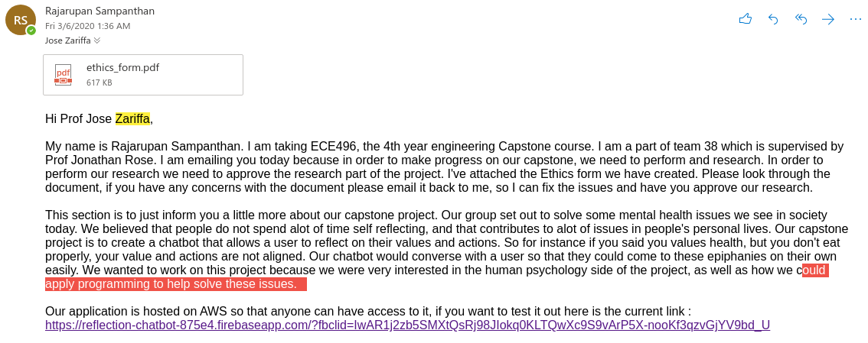



# 

# Appendix M: Ethics Form

**UNIVERSITY OF TORONTO**

Office of the Vice President, Research

Office of Research Ethics

**UNDERGRADUATE ETHICS REVIEW PROTOCOL FORM**

**STUDENT-INITIATED PROJECT**

[**DELEGATED ETHICS REVIEW COMMITTEE**](http://www.research.utoronto.ca/for-researchers-administrators/ethics/human/at-a-glance/initiation/delegated-ethics-review-committees/) **(DERC)** reviewing this project:

**FACULTY SUPERVISOR:**

Name Jonathan Rose Personnel Number 752460

Department Electrical and Computer Engineering

Mailing Address Department of Electrical and Computer Engineering, University of Toronto, 10 King’s College Road, Toronto, Ontario, Canada M5S 3G4

Phone 416-978-6992 Email Jonathan.Rose@ece.utoronto.ca

**PRINCIPAL INVESTIGATOR (UNDERGRADUATE STUDENT):**

Name Rajarupan Sampanthan Student Number 1002477232

Department

Mailing Address 114 Triple Crown Avenue

Phone 6477844019 Email rajarupan.sampanthan@mail.utoronto.ca____

**COURSE:**

Course Title Capstone Design Project

Project Title Reflection Chatbot

Course Code ECE496 Course Start Date 10 September 2019

(The student’s project will be considered completed once the course is over. It is possible, however, to submit an annual renewal form if the project continues beyond the course.)

**MINIMAL RISK AND DELEGATED REVIEW:**

Risk to participants should be proportionate to *student experience* and *pedagogical goals*, with appropriate levels of responsibility and supervision. Typically, undergraduate research should involve *minimal risk*, which means that the probability and magnitude of harm due to participation in the research is no greater than that encountered by participants in their everyday lives. Assessing risk may to some degree be affected by discipline-specific considerations—e.g., forensics, medicine, and nursing may involve work with participants in clinical settings, with attendant requirements for oversight and team qualifications. Departments will likely want to work with the Office of Research Ethics (ORE) to decide how best to handle different levels of risk. Additional on-line resources may also be helpful, including:

* <http://www.research.utoronto.ca/for-researchers-administrators/ethics/> (U of T Office of Research Ethics website)
* <http://pre.ethics.gc.ca/eng/policy-politique/tcps-eptc/readtcps-lireeptc/> (Tri-Council Policy Statement)

* [www.pre.ethics.gc.ca/english/tutorial/](http://www.pre.ethics.gc.ca/english/tutorial/) (TCPS Tutorial)

To evaluate risk for this protocol, consider:

* *Group vulnerability—i.e.,* any pre-existing vulnerabilities associated with proposed participant groups, e.g., relating to pre-existing physiological or health conditions, cognitive or emotional factors, and socio-economic or legal status.
* *Research risk—i.e.,* the probability and magnitude of harms participants may experience as a result of the proposed methods to be used and types of data to be collected, e.g., relating to physiological or health issues such as clinical diagnoses or side effects, cognitive or emotional factors such as stress or anxiety during data collection, and socio-economic or legal ramifications such as stigma, loss of employment, deportation, or criminal investigation (e.g., in the event of duty to report intent to cause serious harm, subpoena, or breach of confidentiality).

Please provide over-all assessments of group vulnerability and research risk (i.e., *low*, *medium*, *high*) and locate the protocol in the matrix, below.

**RISK MATRIX: Review Type by Group Vulnerability and Research Risk--circle one:**

**Research Risk**

**Group vulnerability Low Medium High**

***Low*** ☑ *Delegated* ☑ Delegated Full*

**Medium** Delegated Full* Full*

**High** Full* Full* Full*

*Review by the appropriate REB in Office of Research Ethics

Briefly explain the group vulnerability and research risk, and explain any exceptional circumstances (e.g., student experience) justifying greater than minimal risk:

The study is non-invasive and cannot physically harm the participants. The only ‘risk’ to the participants is that they may be uncomfortable with any questions asked or realizations they have during the conversation with the chatbot. The group of participants who might be severely affected by this issue are those who suffer from extensive mental health issues.

**CO-INVESTIGATORS:**

Are co-investigators involved? *Yes*  No □

If **YES**, provide the name(s) and contact information on a separate sheet.

**HOST SITES:**

Indicate the location(s) where the research will be conducted:

*University of Toronto* □

Affiliated teaching hospital □ _______________________________ (specify site(s))

Community within the GTA □ _______________________________ (specify site(s))

*Other* ☑ Online on a website (specify site(s))

**N.B. If the research is to be conducted at a site requiring administrative approval/consent (e.g., in a school), please include all draft administrative consent letters. It is the responsibility of the researcher to determine what other means of approval are required, and to obtain approval prior to starting the project.**

Other Research Ethics Board Approval:

(a) Does the research involve another institution or site? Yes □  *No* ☑

(b) Has any other REB approved this project? Yes □ *No*  ☑

(c) If **Yes**, please provide a copy of the approval letter upon submission of this application.

(d) If **No**, will any other REB be asked for approval? Yes □  *No* ☑

If **Yes**, please specify which REB ________________

**BACKGROUND, PURPOSE, AND OBJECTIVES:**

Briefly describe the pedagogical goal and scholarly motivation for the project.

The goal of this project is to create a chatbot that will allow the user to reflect on their values and actions. It is an exercise in trying to merge psychology and natural language processing to see if computers can help people directly.

**METHODS AND DATA:**

* If the research takes place in a controlled environment (e.g., clinic, laboratory, formal interview or tests), describe sequentially, and in detail, all procedures in which research participants will be involved.
* If the research involves naturalistic or participant observation, please describe the setting, the types of interactive and observational procedures to be used, and the kinds of information to be collected.
* If the research involves secondary analysis of previously collected data, describe the original source of the data and measures that have been taken to protect data subjects’ identities.
* If the project involves using specialized methods with participants, describe the student’s relevant past experience, or the nature of any supervision they may receive.

**N.B. Attach a copy of all questionnaires, interview guides or other test instruments.**

The researchers will inform possible participants about the experiment by giving them a link to where the chatbot is hosted. Before the users can interact with the chatbot, they must agree to the consent form that pops up on the screen. The user will be informed that they can leave at any time during the conversation, and if they choose to do so, their information will not be studied by the researchers to improve the chatbot . The chatbot will begin conversing with the user, some sample questions the chatbot may ask are provided in the attached document (Appendix A). Once the conversation is completed, the conversation data will be studied. The data will be kept anonymous so it will not be possible to trace a conversation back to a user.

**PARTICIPANTS, INFORMANTS, OR DATA SUBJECTS:**

Describe the individuals whose personal information is to be used as part of the assignment (i.e., in terms of inclusion and exclusion criteria, especially where active recruitment is involved). If the assignment involves working with a vulnerable population, describe the student’s relevant past experience, or the nature of any supervision they may receive.

The participants who will be asked to interact with the chatbot are fellow students, friends and family. These participants will be informed informally about the nature of the research and will be asked to test the chatbot. Anyone of these participants may be suffering from mental health issues, whether they realize it or not. Furthermore it is infeasible for the researchers to do a check on every single individual. To ensure that the vulnerable population receives the necessary supervision, all users will be informed that they can stop the conversation with the chatbot at any time. Moreover they will be told that this conversation data will not be used.

**RECRUITMENT:**

Where there is formal recruitment, please describe how and from where the participants will be recruited. Where participant observation is to be used, please explain the form of insertion of the researcher into the research setting (e.g., living in a community, visiting on a bi-weekly basis, etc.) Where relevant, please explain any non-research relationship between the student and the research participants (e.g., teacher-student, manager-employee, nurse-patient).

**N.B. Attach a copy of any posters, advertisements, flyers, letters, or telephone scripts to be used for recruitment.**

To recruit participants we will focus most of our efforts on our friends, family, contemporaries. The researchers will recruit their friends, family and contemporaries via word of mouth or social media. The researchers will provide a link to chatbot that the participants can use to interact with the chatbot.

The research participants will be mainly friends, families and contemporaries. These participant-researcher relationships include but are not limited to the following: teacher-student, manager-employee, family, friends and partners.

**RISKS:**

Indicate if the participants might experience any of the following risks:

(a) Physical (e.g., bodily contact, administration of any substance)? Yes □ *No* ☑

(b) Psychological/emotional (e.g., feeling embarrassed, anxious, upset)? Yes ☑ *No*□

(c) Social (e.g., possible loss of status, privacy, reputation)? Yes □ *No* ☑

(d) Is there any deception involved (see “Debriefing”, below)? Yes □  *No* ☑

(e) Are risks to participants greater than in their everyday life? Yes □ *No* ☑

If you answered **Yes** to any of the above, please explain the risks, and describe how they will be managed, and how they are proportionate to student experience and pedagogical goals.

Although participation in this study does not expose the participant to great risk, they may feel uncomfortable during the conversation with the chatbot. Whatever revelations a participant may have during the conversation may distress the participant. In this case the chatbot will encourage the user to leave the chatbot if the user feels emotionally distressed. If the user chooses to lend the conversation early, the conversation data will not be saved, and the data will not be used in the study.

**BENEFITS:**

Discuss any potential direct benefits to the participants from their involvement in the project. Comment on potential benefits to the student, the scholarly community, or society that would justify involvement of participants in this study. (See the note on courtesy copies of final reports in the “Debriefing” section, below)

The participants may gain a deeper understanding of themselves and what they want to achieve in life. This project could be used as a tool to help people perform reflective exercises they might not otherwise have a chance to.

**COMPENSATION:**

Will participants receive compensation for participation? *Yes* □ No ☑

FinancialYes □ No ☑ In-kind Yes □ No ☑

Other Yes □ No ☑

(b) If **Yes**, please provide details.

The participants will receive no compensation.

(c) Where there is a withdrawal clause in the research procedure, if participants choose to withdraw, how will you deal with compensation?

There will be no compensation provided if a participant decides to withdraw from the study. It is important to note that their conversation data will not be collected if the user ends the conversation early.

**CONSENT PROCESS:**

Describe the process that the student will use to obtain informed consent. Please note, it is the quality of the consent not the format that is important: if there will be no written consent form, please explain (e.g., if culturally inappropriate). If the research involves extraction or collection of personal information from a data subject, please describe how consent from the individuals or authorization from the custodian will be obtained. For information about the required elements in the information letter and consent form, please refer to:

<http://www.research.utoronto.ca/wp-content/uploads/2010/01/GUIDE-FOR-INFORMED-CONSENT-April-2010.pdf>

**N.B. Where applicable, please attach a copy of the Information Letter/Consent Form, the content of any telephone script, letters of administrative consent or authorization and/or any other material which will be used in the informed consent process.**

The participants will be presented with a consent form before they can interact with the chatbot. By clicking the agree button screen, they will agree to the rules of the study.

If the participants are children, or are not competent to consent, describe the proposed alternate source of consent, including any permission/information letter to be provided to the person(s) providing the alternate consent as well as the assent process for participants.

n/a

Where applicable, please describe how the participants will be informed of their right to withdraw from the project. Outline the procedures which will be followed to allow them to exercise this right.

The participants will receive an initial message from the chatbot to inform them they are talking to a chatbot and their conversation will be used for research purposes. They will be allowed to stop at any time. There will also be a section on the consent form that will inform them of this right. Furthermore if the chatbot detects any distress, it will remind the participants to withdraw.

Indicate what will be done with the participant’s data and any consequences which withdrawal may have on the participant.

The data will be used to train the chatbot, and studied to help us fine tune how to chatbot’s behavior. There will be no consequences for the participant.

If the participants will not have the right to withdraw from the project at all, or beyond a certain point, please explain.

n/a

**PRIVACY AND CONFIDENTIALITY:**

Will the data be treated as confidential? *Yes* ☑ No □

If **Yes**, please describe the procedures to be used to protect confidentiality during the conduct of research and in preparation of the final report.

The conversation data will be stored confidentially. Although the conversation data will not be altered, the conversation data will not be linked to any IP addresses or users, so it will not be possible to link a conversation to a specific person.

Explain how written records, video/audio tapes and questionnaires will be stored (e.g., password protected computer, double locked office and filing cabinet), and provide details of their final disposal or retention schedule. Data security measures should be consistent with U of T’s [*Data Security Standards for Personally Identifiable and Other Confidential Data in Research*](http://www.research.utoronto.ca/ethics/pdf/human/nonspecific/datasecurity.pdf):

The data will be stored on a private Github account, and all of the conversations with the chatbot will be numbered, so no user-identifying information is stored. Once the project is completed, all data will be deleted.

We will be using AWS (Amazon Web Services) servers to transfer data from the user to a private Github account. There will be no conversation data stored on AWS, and all the data that travels through AWS is encrypted, which ensures confidentiality when we recieve the data from AWS.

If **No**—i.e., confidentiality is not appropriate in the context of this assignment—please explain (e.g., participants are key informants with established reputations in their field).

n/a

**DEBRIEFING:**

Explain what information (e.g., research summary) will be provided to the participants after participation in the project. If deception will be used in the research study, please explain what information will be provided to the participants after participation in the project—if applicable, attach a copy of the written debriefing form.

**N.B. Please note that all copies of the students’ final reports—e.g., for circulation as courtesy copies, or future writing samples—must clearly indicate on the cover page the instructor, course number, and department or program at the University of Toronto that the report was prepared for.**

The participants will not have access to any data. There will be no deception used in this study.

**Consent Form**

**Reflection Chat-bot Engineering Capstone Design Project**

We would like to invite you to participate in our project, as part of the University of Toronto’s

Engineering Capstone Design Project. Please read the explanation about the project and its risks and benefits before you decide to participate. Feel free to ask us any

questions you would like clarified before making a decision.

Our goal for this project is to create a chatbot that is able to help a person reflect on their actions and values. To accomplish this, large amounts of conversation data is needed. The data will be used to adjust the chatbot to real world users and to improve the chatbot's ability to converse. Thus the purpose of this research is to see how different users react to the chatbot and what kind of responses the users offer. This will allow the investigators to improve the bot, and to measure how users respond to it.

You will be required to talk to the chatbot. You may converse with the bot as long as you want. The questions the chatbot asks may cause emotional discomfort in some individuals..

Your participation is voluntary and you may decline to participate. Also, you may withdraw at any time without any negative consequences. All information obtained will be held in strict confidence. If you do not complete the conversation with the chatbot, the data will not be collected. Please understand that there is no compensation for participating in this experiment.

It is important to note that this application will use AWS (AMazon Web Services). There will be no data stored on these servers, but all data will be transferred to us on a private Github account.

If you have any questions or concerns, you can contact the Principal Investigator, Rajarupan Sampanthan at rajarupan.sampanthan@mail.utoronto.ca. You can also contact the Office of Research Ethics at the University of Toronto at ethics.review@utoronto.ca or at 416-946-3273 to inquire about your rights as participants or any other concerns.

By agreeing to click the “I agree” below, you are indicating that you have carefully read the information provided above and are agreeing to participate in the experiment.

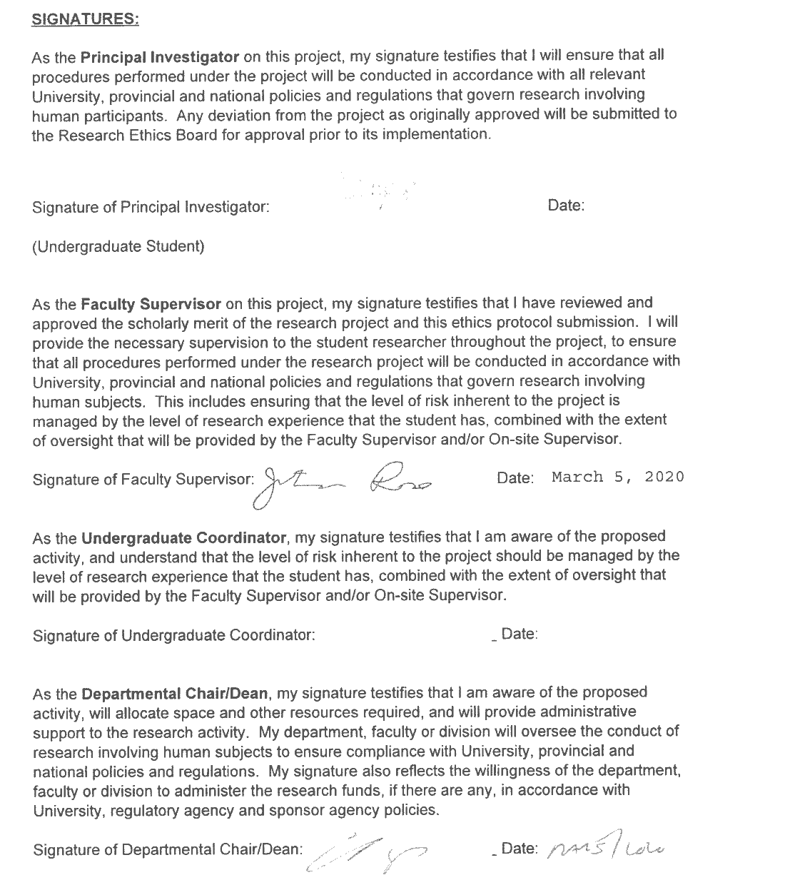

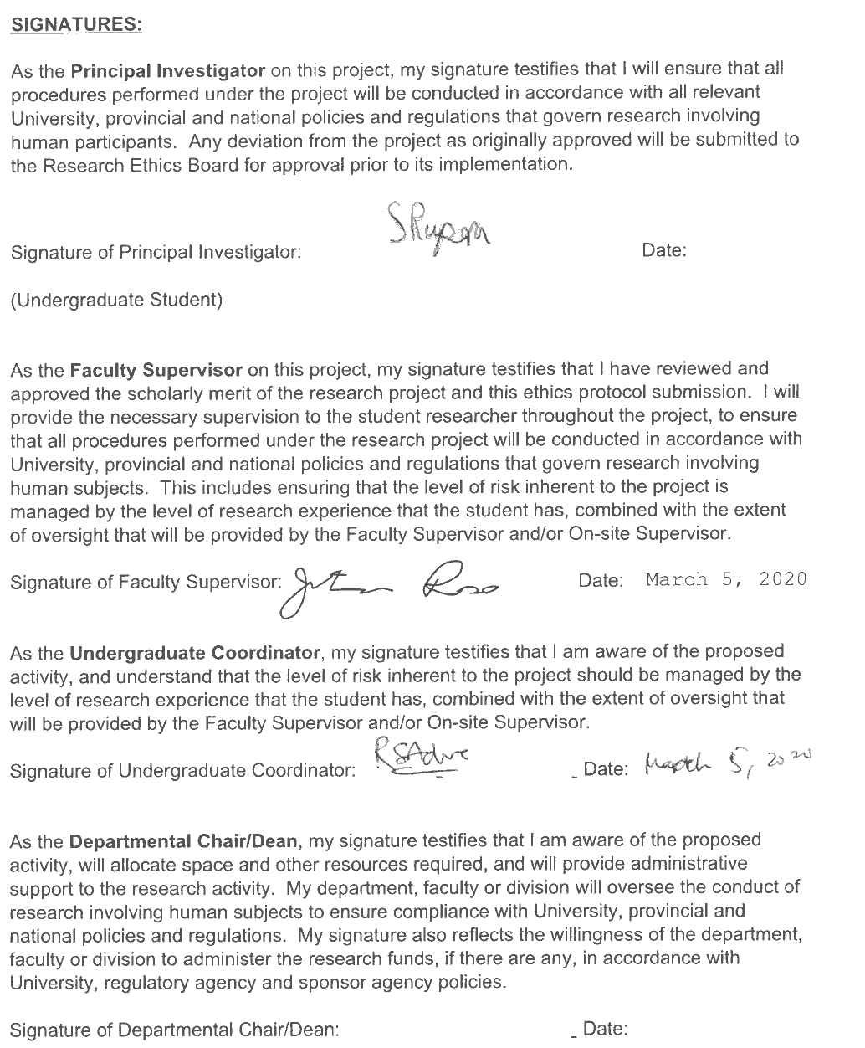

Appendix A : Sample Questions

1. Please group the following values into 1 of 3 categories; most important, important, least important

2. Please rank the most important values (Chatbot could select top 5 to discuss)

3a. Please describe your strengths.

3b. Please describe your weaknesses.

4. Determine how user spends their time:

a) For a given week, what do you spend time doing? If possible please assign a percentage to each activity.

b) Now looking more big picture, in the past year, what have you spent your time doing?

c) Say you were given a year to do whatever you wanted, what would you do?

Thank you this has given me a better sense of who you are. I'd now like to ask you more about some of your values.

4.5. Do you have an important value previously chosen you would like to improve on?

5. For each value (top 5 important ones or the one chosen)

a) Why did you pick this as one of your most important values? How did it become one of your core values?

b) How would you say you express this value in your life?

c) Can you describe an event when you feel you embodied this value or the value had a large impact on influencing the event?

1) How long ago was this? Do events such as this happen often?

2) How did that make you feel?

d) How well do you feel your actions and how you spend your time reflect this value?

e) Do you have any goals surrounding this value? Please describe why you want to reach them.

1) Are you in the progress of achieving this goal?

- If not, what causes the stagnation? What is the result of it?

f) What is preventing you from reaching this goal?

g) Do you think that the activities help you achieve your goal?

1) Which particular activities?

h) How would you like to be spending your time differently to better reflect this value?

1) Why isn't this the case?

i) What sort of plan do you think you could create to begin on the path to this change?

j) Were there any events that you felt negatively because you didn't prioritize this value?

1) What prevented you from prioritizing this value?

2) How would you have done to change the outcome of the event?

3) How did that make you feel?

Quantifying questions for quality of the tool:

a) On of scale of 1-10, how...

1) useful?

2) relevent?

3) well do you intent to make changes?

4) much are you motivated?

5) close is this to what you need?

Co-Researcher Information

**INVESTIGATOR (UNDERGRADUATE STUDENT):**

Name Kuan Ying Chern Student Number 1002047395

Department Electrical and Computer Engineering

Mailing Address #1112 - Grandview Way, Toronto

Phone 6476313569 Email tim.chern@mail.utoronto.ca

**INVESTIGATOR (UNDERGRADUATE STUDENT):**

Name J. Matthew Chapleau Student Number 1002520097

Department Electrical and Computer Engineering

Mailing Address 63 Lunau Lane, Thornhill ON

Phone 6472156077 Email matthew.chapleau@mail.utoronto.ca

**INVESTIGATOR (UNDERGRADUATE STUDENT):**

Name Shihan Zhang Student Number 1002055795

Department Electrical and Computer Engineering

Mailing Address 89 Chestnut Street

Phone 6478675395 Email cora.zhang@mail.utoronto.ca

# Appendix N: Motivational Interview Transcripts Email

